

Installation guide on ABAP SDK on Azure

|  |  |  |  |
| --- | --- | --- | --- |
| **Version No.** | **Date** | **Name** | **Description of change** |
| 1.0 | MAY, 2018 | Installation Guide ABAP SDK for Azure | Initial version |
|  |  |  |  |

Table of Contents

1. Introduction 3

2. Classes used in Azure SDK for ABAP 3

3. Dictionary Objects 4

4. Table maintenance Objects 14

5. ABAP Classes and Methods 14

6. Future Modification on Installation Guide 39

# Introduction

Microsoft Azure is a growing collection of integrated cloud services which developers and IT professionals use to build, deploy and manage applications through our global network of datacenters.

Azure provides various services and products to:

* Store the data
* Analyse the data
* Integrate the data
* Get Application Insights
* Get Business Insights and so on

Most of Azure products have their own respective REST end points, Authentication and Authorization mechanisms, Storages, Data formats, troubleshooting mechanisms, Notifications, etc and Azure provides SDK’s and tools for various programming languages to integrate to its products. We have SDKs for Java, .NET, Node JS, PHP, Python and few other languages but they don’t exist for SAP ABAP.

Azure prospective customers with SAP installations require in depth knowledge of security and Integration patterns of the respective Azure services, making it complex for enterprises to integrate SAP with Azure services. To overcome this challenge, Microsoft IT has created ABAP SDK for Azure to simplify our SAP integration with Azure.

This SDK is the built using SAP’s proprietary language ABAP and its supporting configuration tools. The framework enables the programmer to integrate with Azure services by abstracting the complexity like authentication, shared access tokens, security etc.

This Document is intended to explain the technical details on **Azure SDK for ABAP** for SAP ABAP programmers to connect to Azure Products seamlessly with minimal knowledge on Azure.

# Classes used in Azure SDK for ABAP

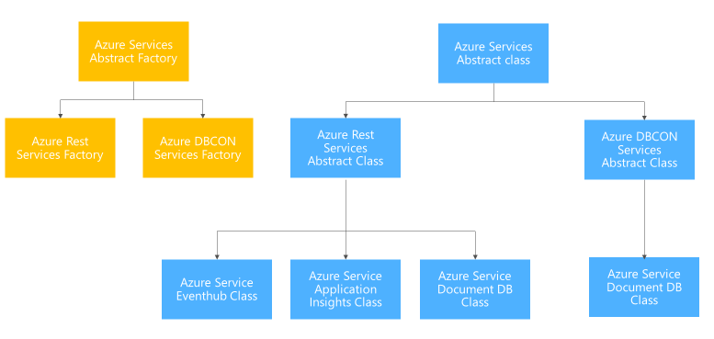

We have used Abstract factory design pattern to design and develop the Azure SDK for ABAP libraries. This pattern allows us to enhance and extend the libraries easily to all the Azure Cloud Services. Each Azure cloud Service is assigned with an Interface Type ID which shall be used to create the instance of the required Azure Cloud Service class instance. Once the class is instantiated, data which needs to be transferred to Azure cloud shall be passed to Send method along with the mandatory attributes, SDK would take care of generating the necessary security tokens or SAS tokens for the Azure Cloud Services and will post the data to the respective end points securely.

# Dictionary Objects

Table 1: ZADF_CONFIG 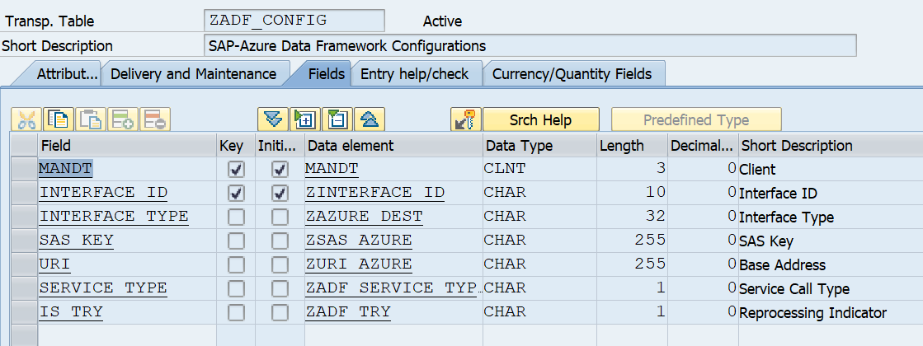

|  |  |  |  |  |  |
| --- | --- | --- | --- | --- | --- |
| Field | Key | Data Element | Data Type | Length | Description |
| MANDT | Y | MANDT | CLNT | 3 | Client |
| INTERFACE_ID | Y | ZINTERFACE_ID | CHAR | 10 | Interface ID |
| INTERFACE_TYPE |  | ZAZURE_DEST | CHAR | 32 | Interface Type |
| SAS_KEY |  | ZSAS_AZURE | CHAR | 255 | SAS Key |
| URI |  | ZURI_AZURE | CHAR | 255 | Base Address |
| SERVICE_TYPE |  | ZADF_SERVICE_TYPE | CHAR | 1 | Service Call Type |
| IS_TRY |  | ZADF_TRY | CHAR | 1 | Reprocessing Indicator |

Table2: ZADF_CON_INDX

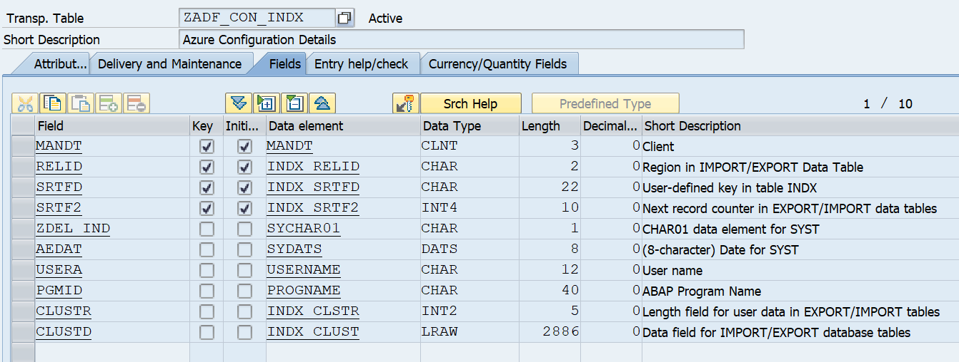

|  |  |  |  |  |  |
| --- | --- | --- | --- | --- | --- |
| Field | Key | Data Element | Data type | Length | Description |
| MANDT | Y | MANDT | CLNT | 3 | Client |
| RELID | Y | INDX_RELID | CHAR | 2 | Region in IMPORT/EXPORT Data Table |
| SRTFD | Y | INDX_SRTFD | CHAR | 22 | User-defined key in table INDX |
| SRTF2 | Y | INDX_SRTF2 | INT4 | 10 | Next record counter in EXPORT/IMPORT data tables |
| ZDEL_IND |  | SYCHAR01 | CHAR | 1 | CHAR01 data element for SYST |
| AEDAT |  | SYDATS | DATS | 8 | (8-character) Date for SYST |
| USERA |  | USERNAME | CHAR | 12 | User name |
| PGMID |  | PROGNAME | CHAR | 40 | ABAP Program Name |
| CLUSTR |  | INDX_CLSTR | INT2 | 5 | Length field for user data in EXPORT/IMPORT tables |
| CLUSTD |  | INDX_CLUST | LRAW | 2886 | Data field for IMPORT/EXPORT database tables |

Table 3: ZADF_EHUB_POLICY

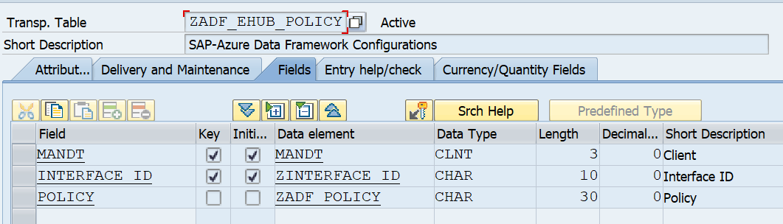

|  |  |  |  |  |  |
| --- | --- | --- | --- | --- | --- |
| Field | Key | Data Element | Data Type | Length | Description |
| MANDT | Y | MANDT | CLNT | 3 | Client |
| INTERFACE_ID | Y | ZINTERFACE_ID | CHAR | 10 | Interface ID |
| POLICY |  | ZADF_POLICY | CHAR | 30 | Policy |

**Complete Data element List:**

ZADF_FORMAT_TYPE SAP-Azure Data Framework Format Type

ZADF_POLICY Policy

ZADF_SERVICE_ID SAP-Azure Data Framework Service Id

ZADF_SERVICE_TYPE Service Call Type

ZADF_TRY Reprocessing Indicator

ZAZURE_DEST Interface Type

ZSAS_AZURE SAS Key

ZURI_AZURE Base Address

**Complete Domain List:**

ZADF_FORMAT_TYPE SAP-Azure Data Framework Format Type

ZADF_POLICY Security policy

ZADF_SERVICE_TYPE Service Call Type

ZADF_TRY Reprocessing Indicator

ZAZURE_DEST Interface Type

ZSAS_AZURE Domain for SAS Key

ZURI_AZURE Base Address

**Dictionary objects specific to ‘ZREST’ Package:**

1. ZHEADER_STRUCTURE

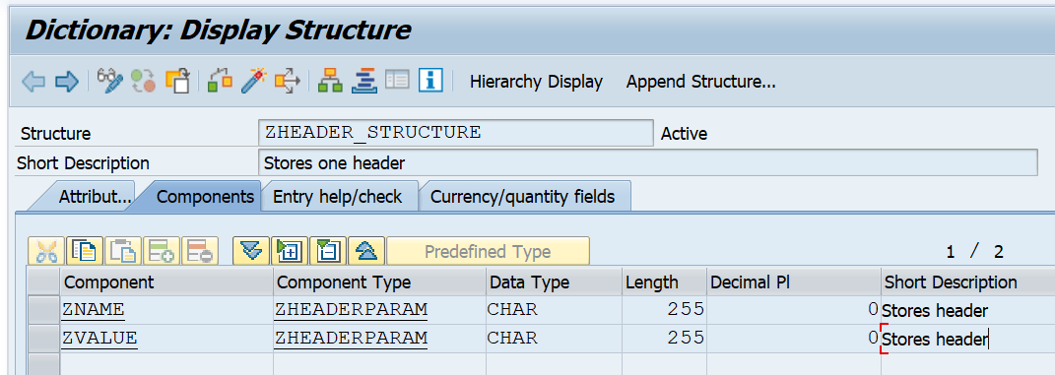

1. ZNAMEVALUEPAIR

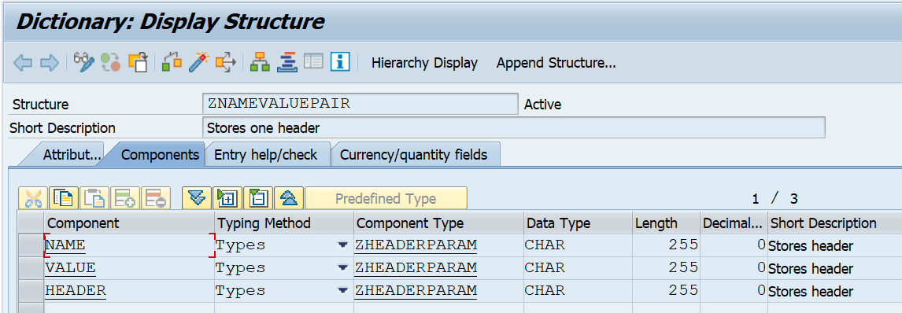

1. ZRT_APPLOG_MESSAGE

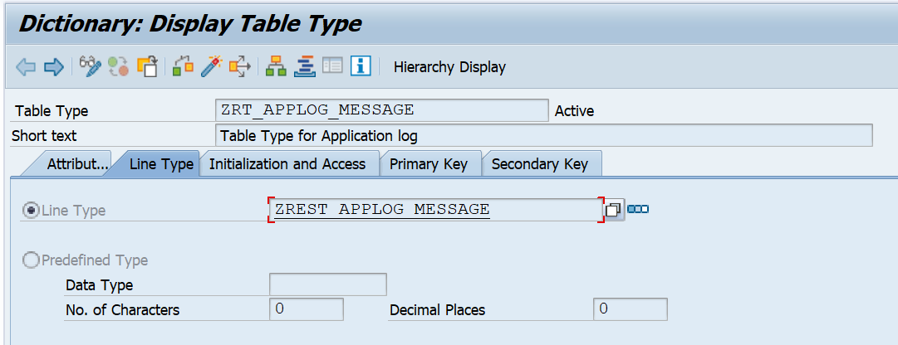

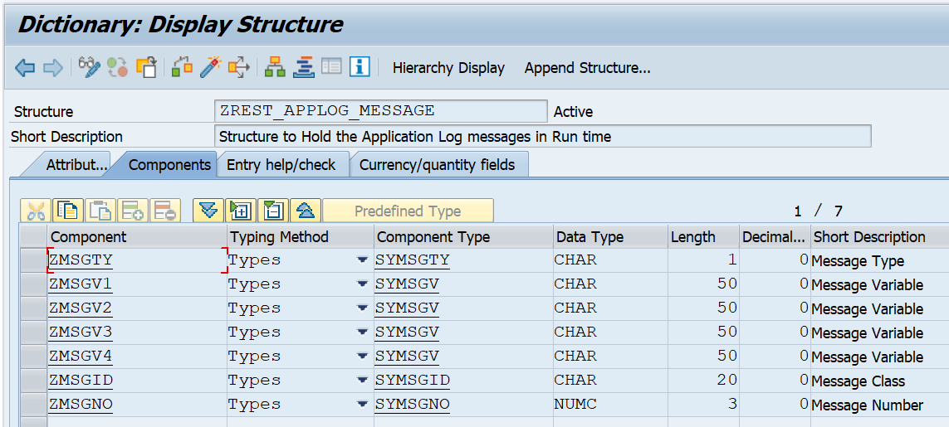

1. ZOBFUSCATE

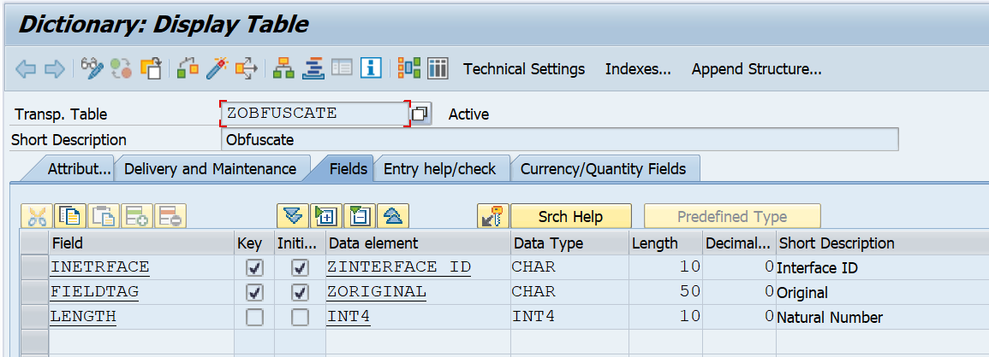

1. ZREST_CONFIG

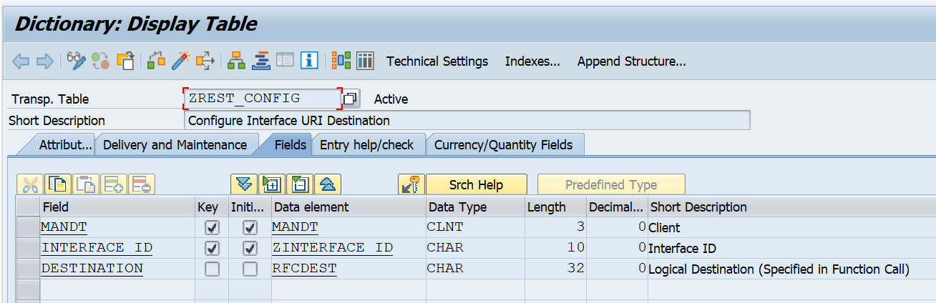

1. ZREST_CONF_HEAD

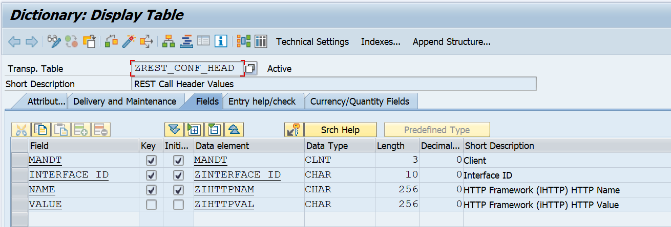

1. ZREST_CONF_MISC

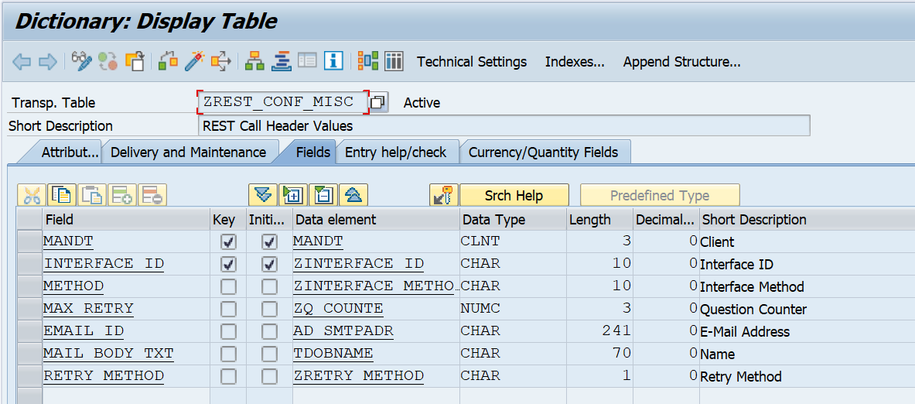

1. ZREST_GLOBAL

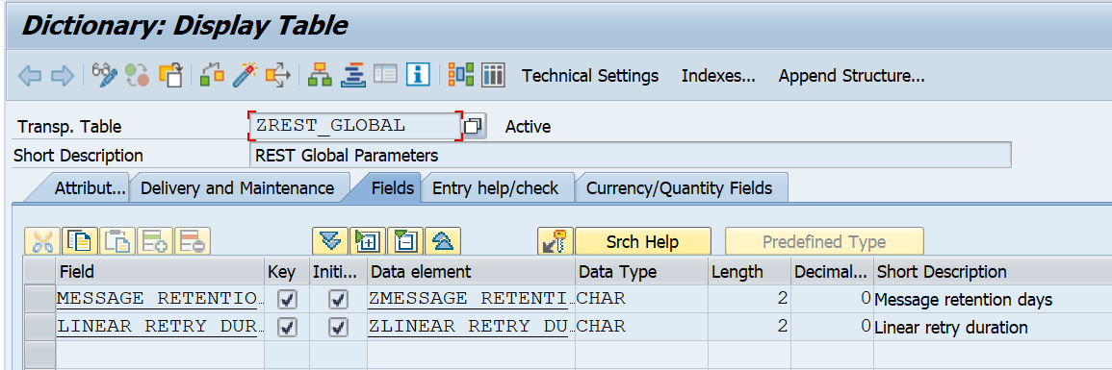

1. ZREST_MONITOR

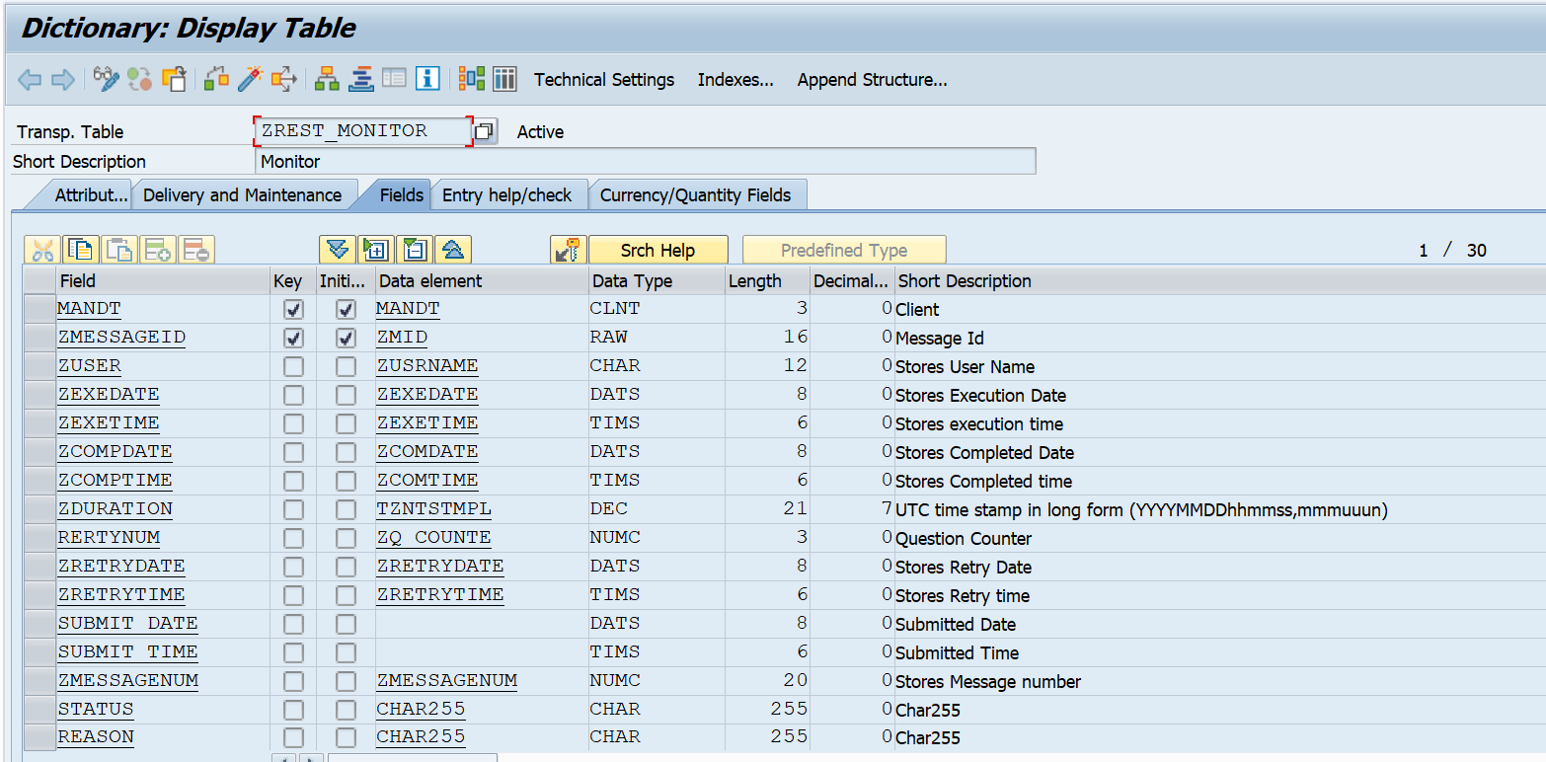

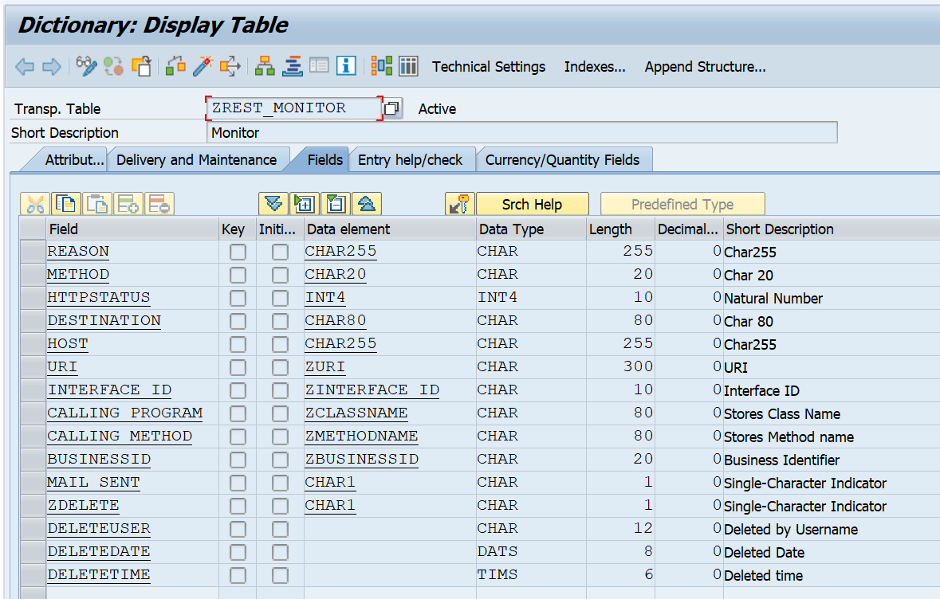

1. ZREST_MONITORLOG

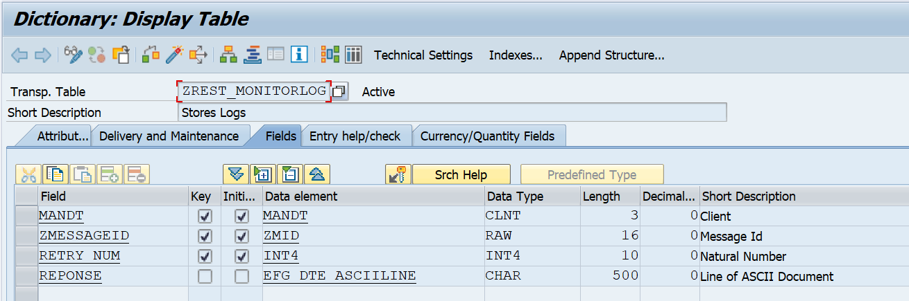

1. ZREST_MON_HEADER

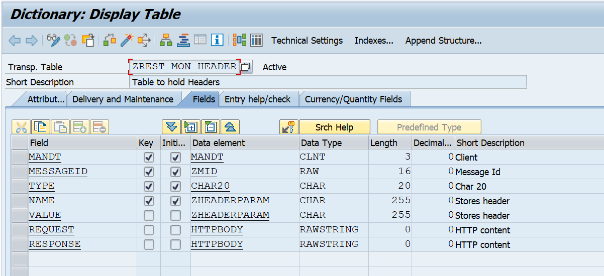

1. ZREST_MON_TRACE

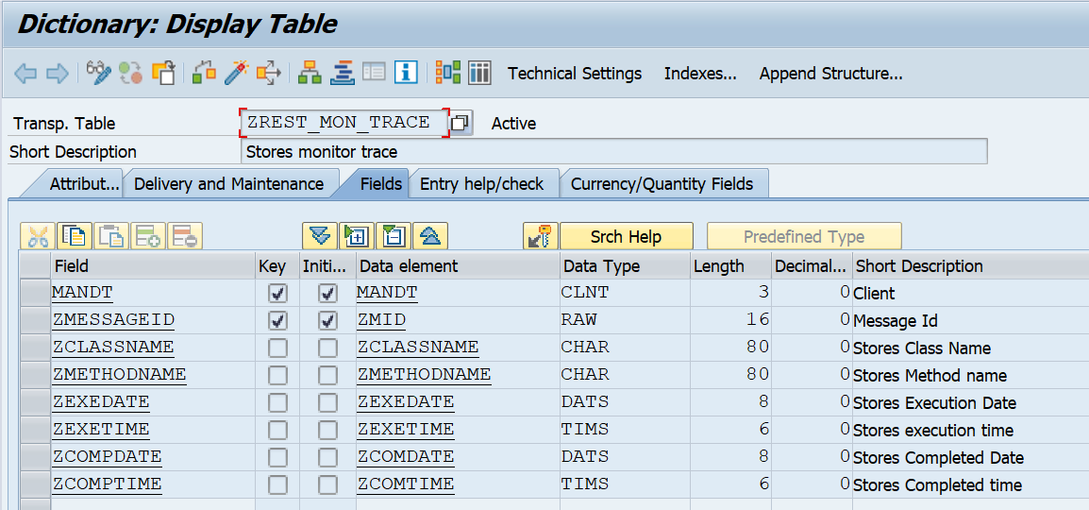

1. ZREST_MO_PAYLOAD

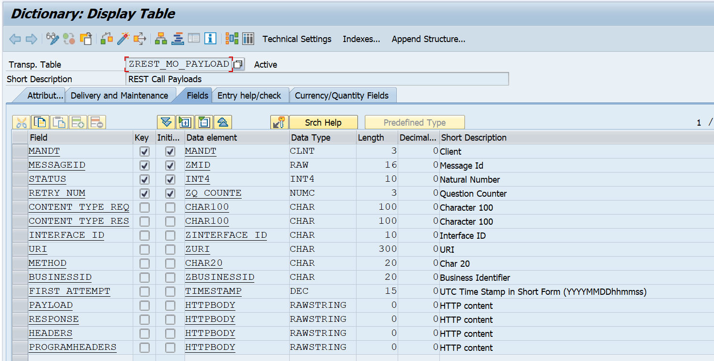

1. ZREST_RETRIES

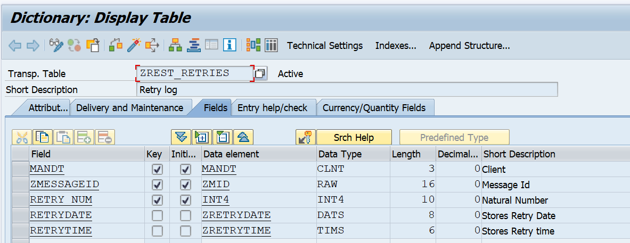

1. ZREST_RETRY_LIMI

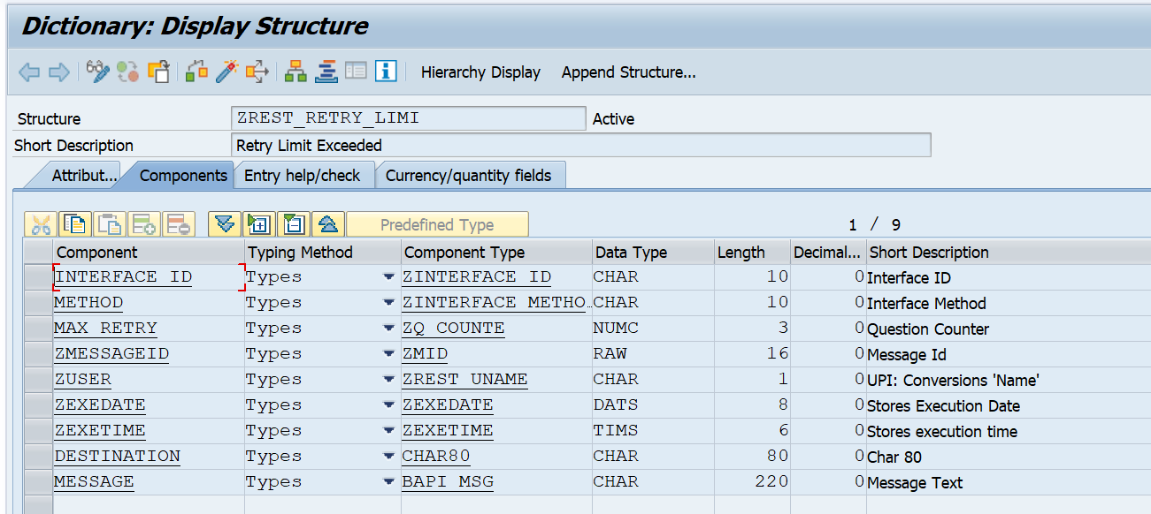

1. ZREST_SRTUCT_CONFIG

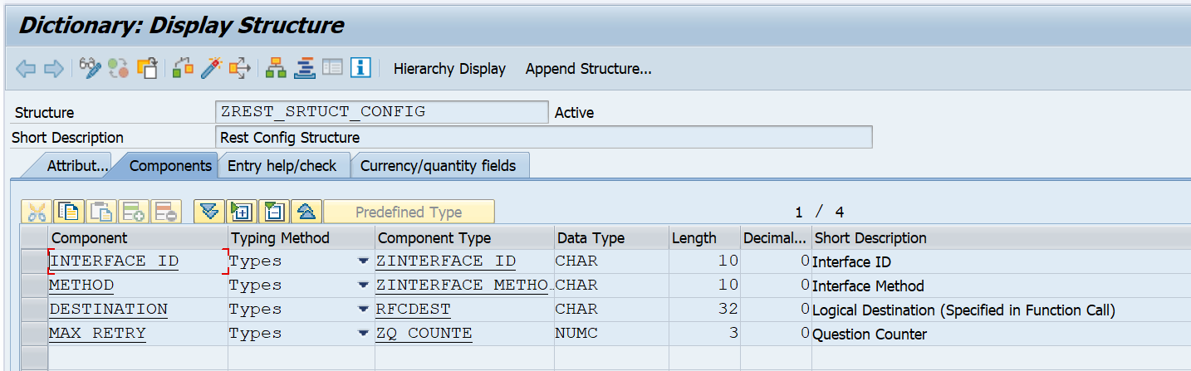

# Table maintenance Objects

Table maintenance objects should be created for below tables.

* ZADF_CONFIG

Refer table events and its corresponding code for table ZADF_CONFIG in code repository section.

* ZEHUBPOLICY

# ABAP Classes and Methods

Below mentioned classes and methods to be created. Refer its corresponding logic and signature of each method in the repository section . Prior to this, implement Package ‘ZREST’ by referring the code repository section.

Package ‘ZREST’ Includes the following objects.

**ZREST Package Object lists**

|  |  |
| --- | --- |
| **OBJECT_TYPE** | **OBJECT_NAME** |
| CLAS | ZCL_REST_FRAMEWORK |
| CLAS | ZCL_REST_UTILITY_CLASS |
| CLAS | ZCX_HTTP_CLIENT_FAILED |
| CLAS | ZCX_INTERACE_CONFIG_MISSING |
| CLAS | Z_RESTCALL_FROM_DB |
| DEVC | ZREST |
| DOMA | ZBASEURI |
| DOMA | ZCLASSNAME |
| DOMA | ZDIHTTPNAM |
| DOMA | ZDIHTTPVAL |
| DOMA | ZD_ORGINAL |
| DOMA | ZHEADERPARAM |
| DOMA | ZINTERFACE_ID |
| DOMA | ZLINEAR_RETRY_DURATION |
| DOMA | ZMESSAGENUM |
| DOMA | ZMESSAGE_RETENTION |
| DOMA | ZMETHODNAME |
| DOMA | ZQ_COUNTE |
| DOMA | ZREST_UCHAR1 |
| DOMA | ZRETRY_METHOD |
| DOMA | ZUCHAR1 |
| DTEL | ZBUSINESSID |
| DTEL | ZCLASSNAME |
| DTEL | ZCOMDATE |
| DTEL | ZCOMTIME |
| DTEL | ZEXEDATE |
| DTEL | ZEXETIME |
| DTEL | ZHEADERPARAM |
| DTEL | ZIHTTPNAM |
| DTEL | ZIHTTPVAL |
| DTEL | ZINTERFACE_ID |
| DTEL | ZINTERFACE_METHOD |
| DTEL | ZLINEAR_RETRY_DURATION |
| DTEL | ZMESSAGENUM |
| DTEL | ZMESSAGE_RETENTION |
| DTEL | ZMETHODNAME |
| DTEL | ZMID |
| DTEL | ZORIGINAL |
| DTEL | ZQ_COUNTE |
| DTEL | ZREST_UCHAR1 |
| DTEL | ZREST_UNAME |
| DTEL | ZRETRYDATE |
| DTEL | ZRETRYTIME |
| DTEL | ZRETRY_METHOD |
| DTEL | ZUNAME |
| DTEL | ZURI |
| DTEL | ZUSRNAME |
| ENQU | EZ_ZREST_MONITOR |
| ENQU | EZ_ZREST_PAYLOAD |
| ENQU | EZ_ZREST_RETRY |
| FUGR | ZREST |
| INTF | ZIF_REST_FRAMEWORK |
| MSAG | Z_FI_MDG |
| PROG | ZREST_CALL_DEMO |
| PROG | ZREST_SCHEDULER |
| PROG | ZREST_SCREEN |
| PROG | ZREST_SEND_MAIL_MAX_RETRY |
| PROG | ZTEST_HTTP_REST_FO1 |
| PROG | ZTEST_HTTP_REST_I01 |
| PROG | ZTEST_HTTP_REST_O01 |
| PROG | ZTEST_HTTP_REST_TOP |
| TABL | ZHEADER_STRUCTURE |
| TABL | ZNAMEVALUEPAIR |
| TABL | ZOBFUSCATE |
| TABL | ZREST_APPLOG_MESSAGE |
| TABL | ZREST_CONFIG |
| TABL | ZREST_CONF_HEAD |
| TABL | ZREST_CONF_MISC |
| TABL | ZREST_GLOBAL |
| TABL | ZREST_MONITOR |
| TABL | ZREST_MONITORLOG |
| TABL | ZREST_MON_HEADER |
| TABL | ZREST_MON_TRACE |
| TABL | ZREST_MO_PAYLOAD |
| TABL | ZREST_RETRIES |
| TABL | ZREST_RETRY_LIMI |
| TABL | ZREST_SRTUCT_CONFIG |
| TOBJ | ZOBFUSCATES |
| TOBJ | ZREST_CONFIGS |
| TOBJ | ZREST_CONF_HEADS |
| TOBJ | ZREST_CONF_MISCS |
| TOBJ | ZREST_GLOBALS |
| TRAN | ZREST_UTIL |
| TTYP | ZHEADER_TABLE |
| TTYP | ZNAME_VALUE_TAB |
| TTYP | ZRT_APPLOG_MESSAGE |
| TTYP | ZRT_HEADER_LOG |
| TTYP | ZRT_MONITOR |
| TTYP | ZRT_MONITORLOG |
| TTYP | ZRT_PAYLOAD |
| TTYP | ZTOBFUSCATE |
| TTYP | ZTT_REST_RETRY_LIMI |

1. **ZIF_REST_FRAMEWORK**

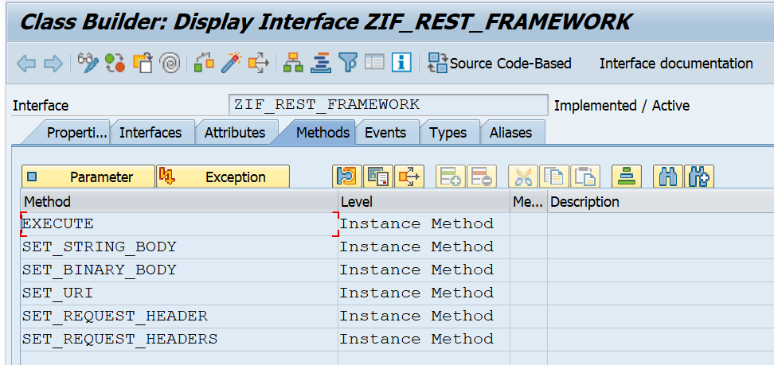

1. **ZCL_REST_FRAMEWORK**

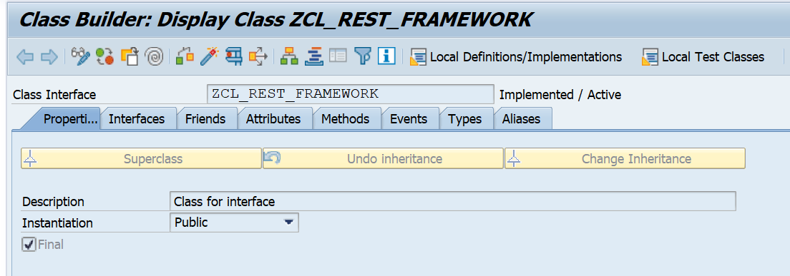

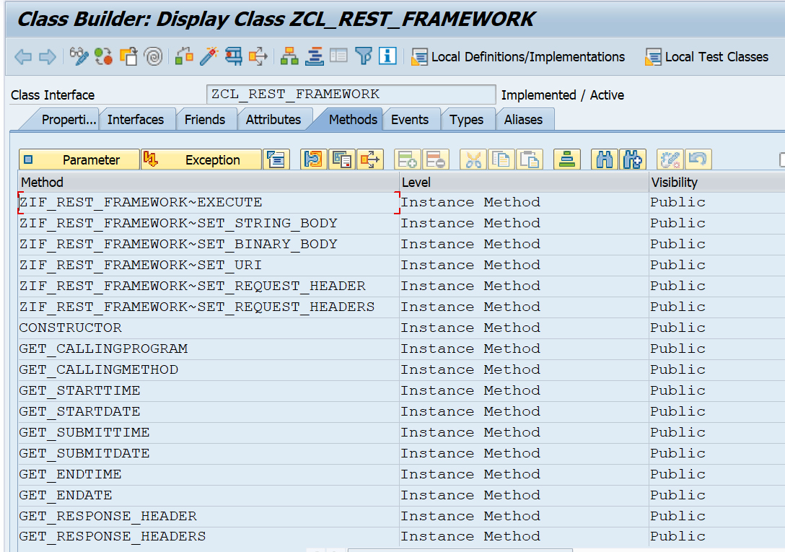

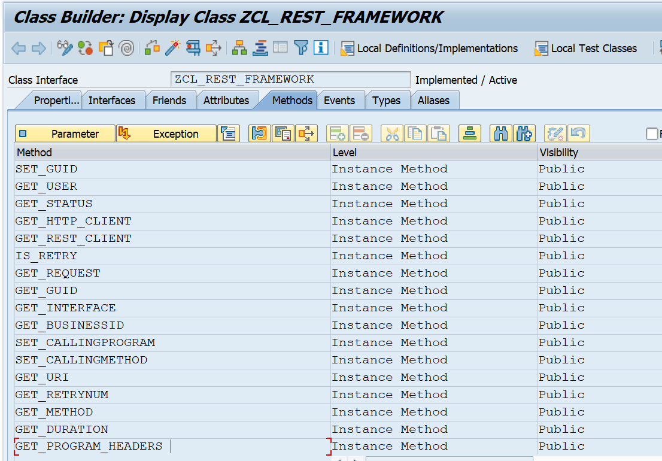

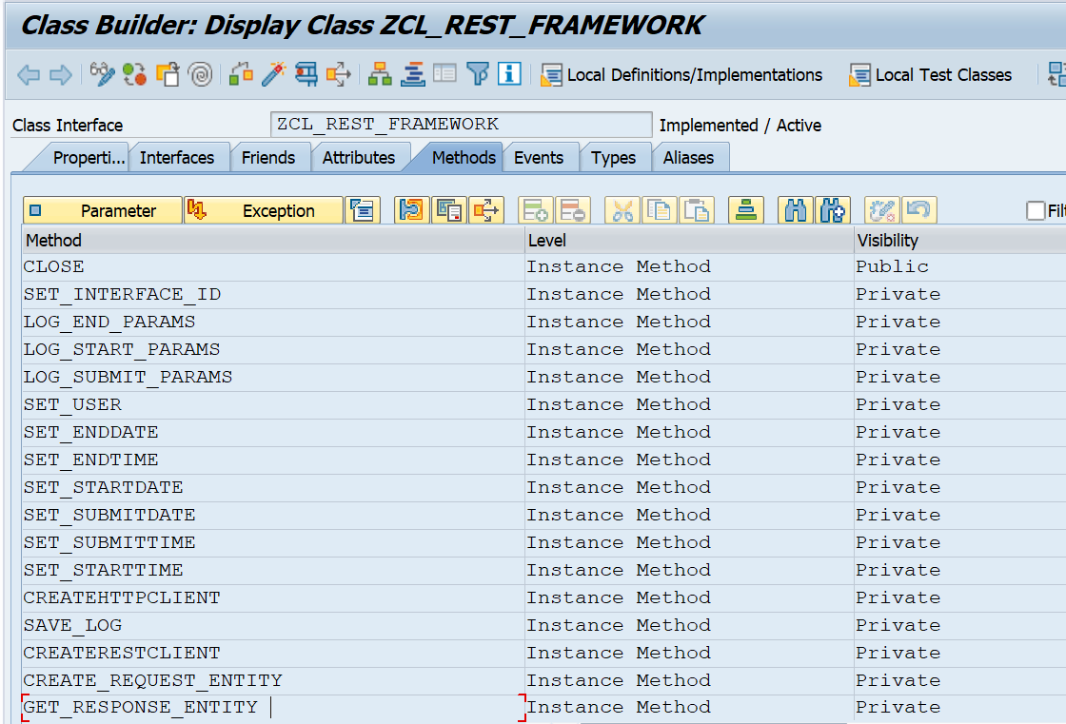

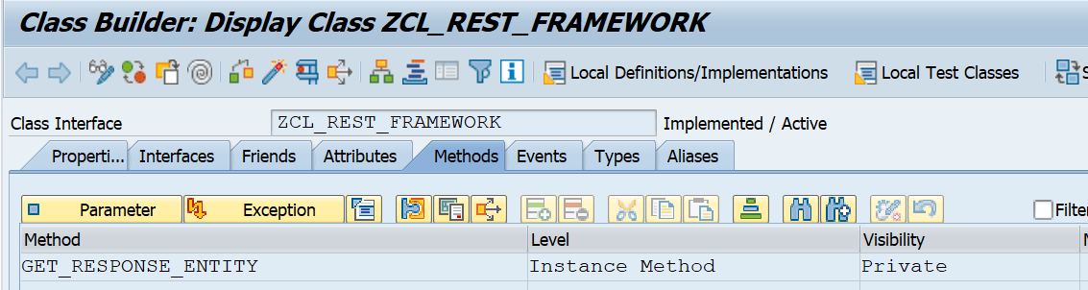

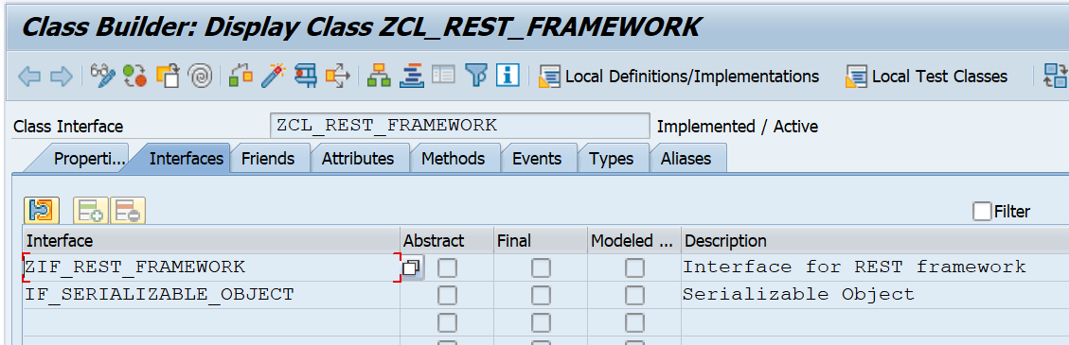

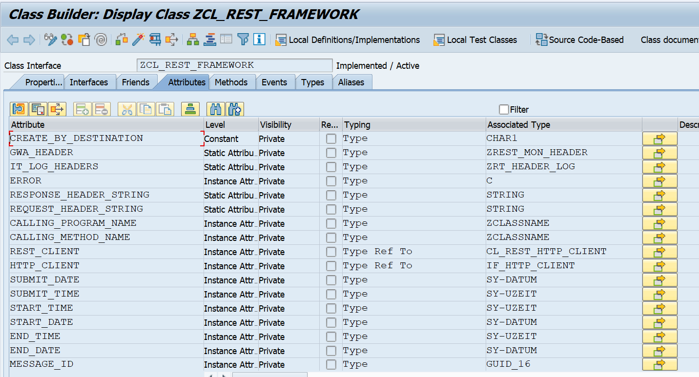

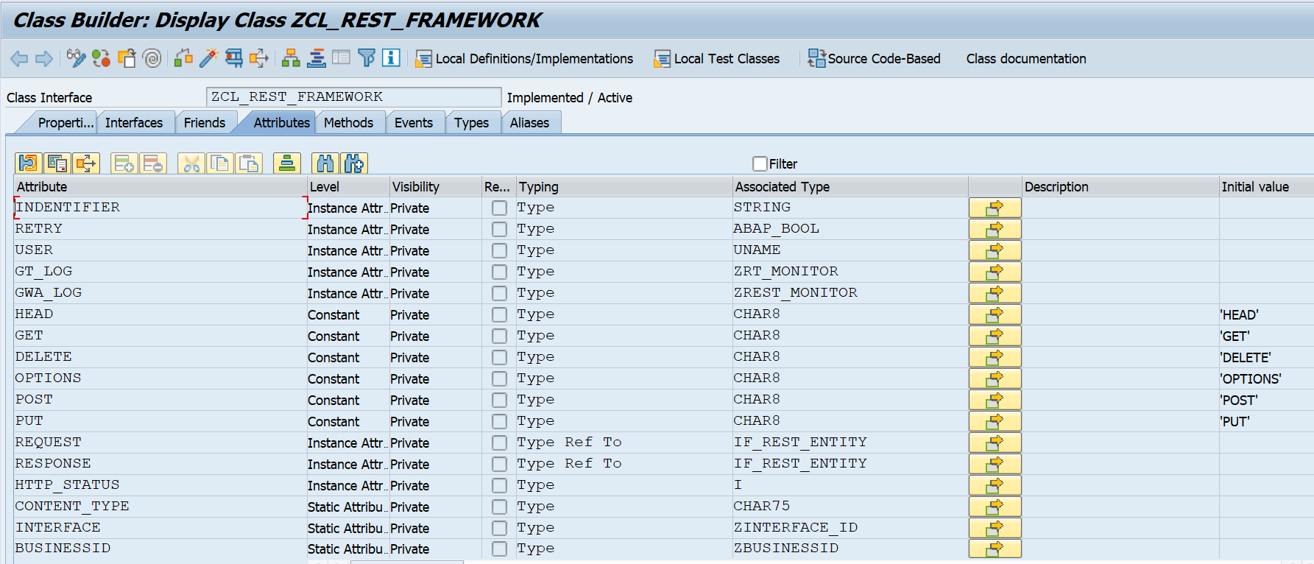

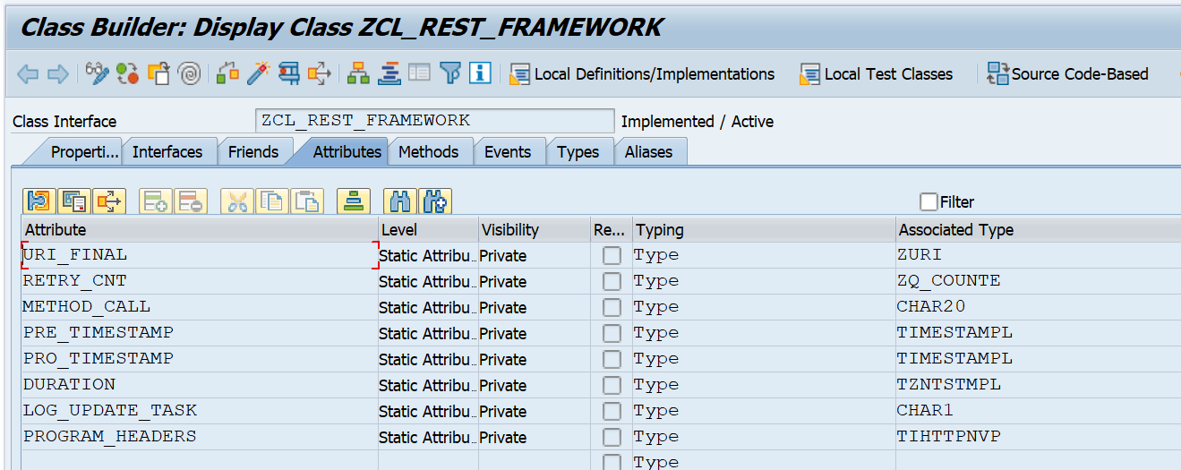

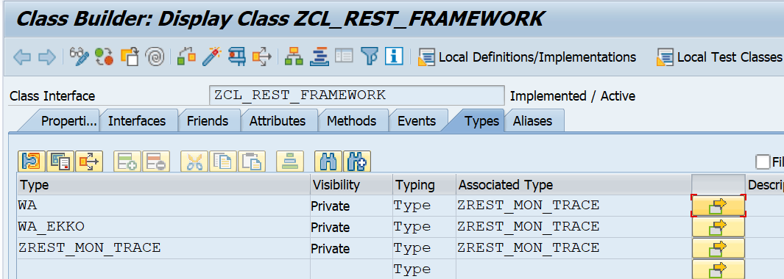

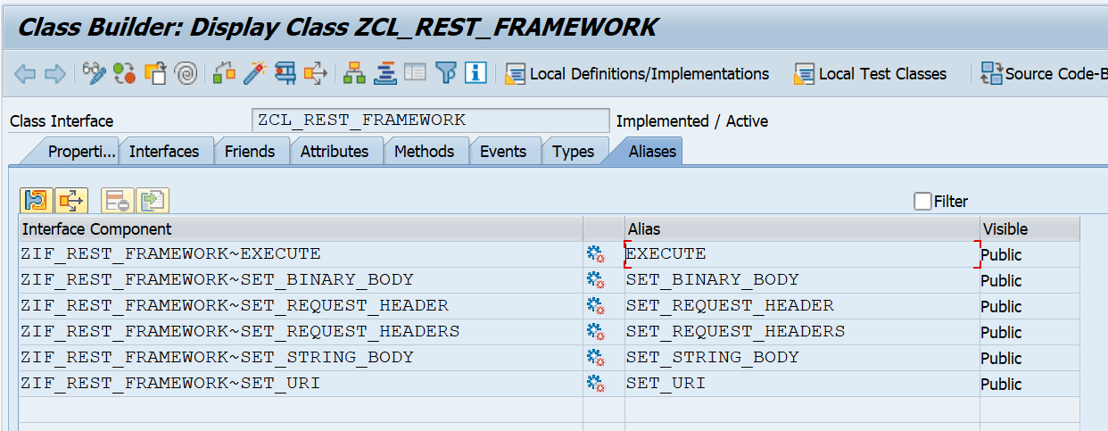

1. **ZCL_REST_UTILITY_CLASS**

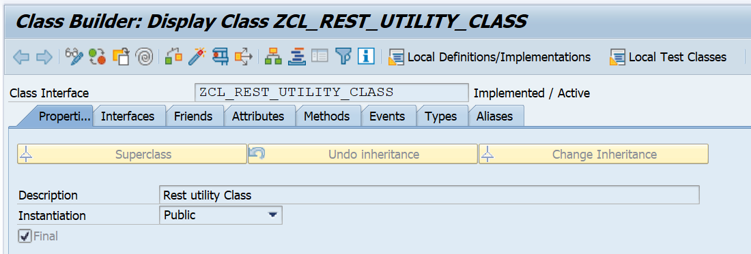

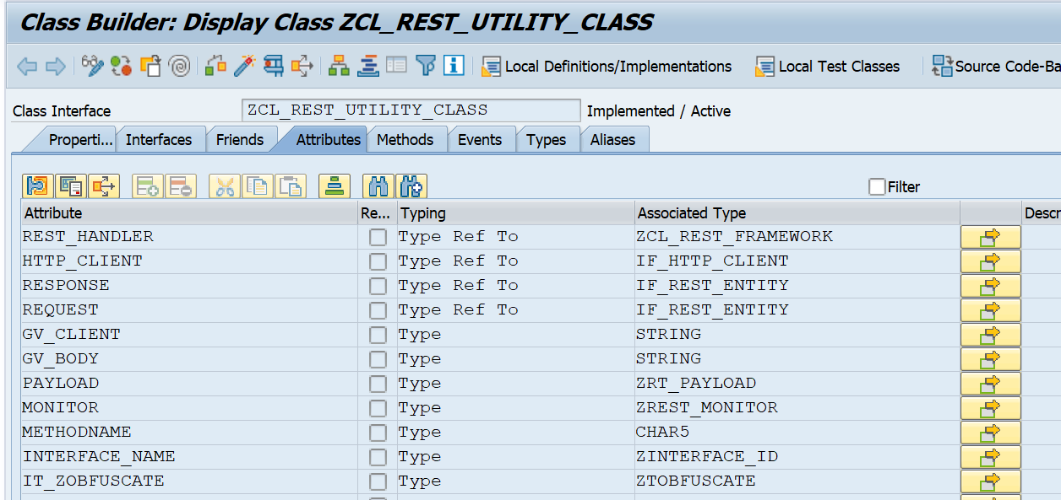

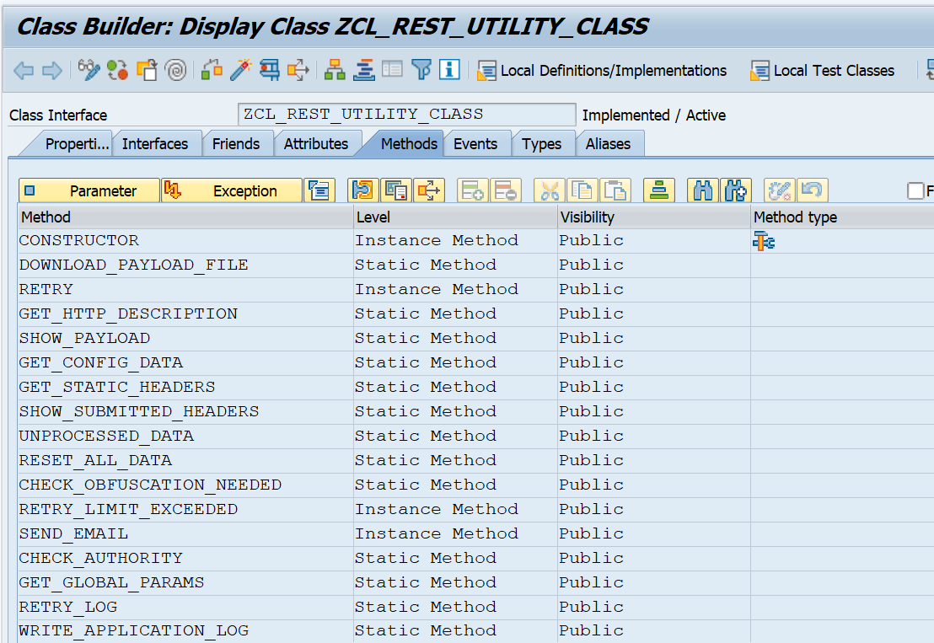

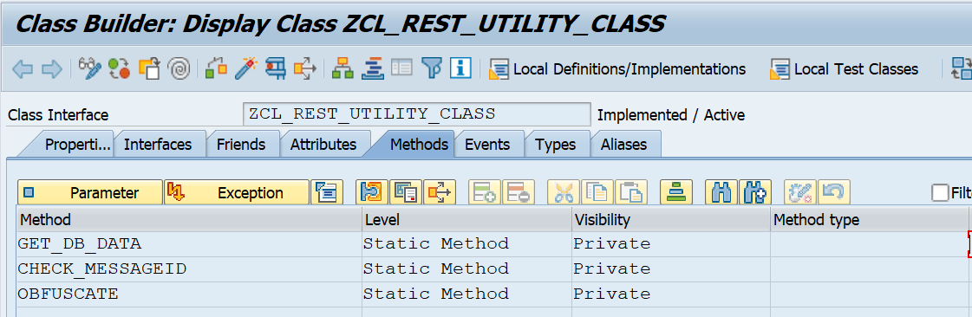

1. **ZCX_HTTP_CLIENT_FAILED**

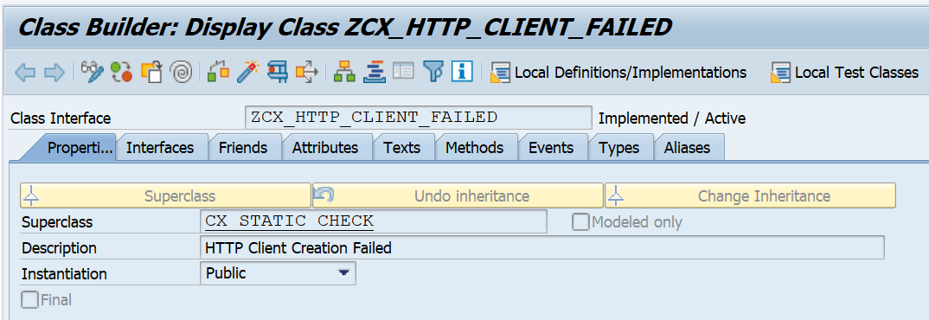

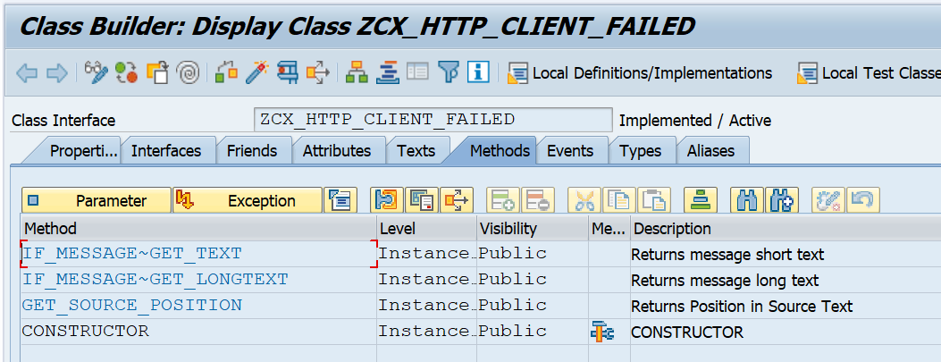

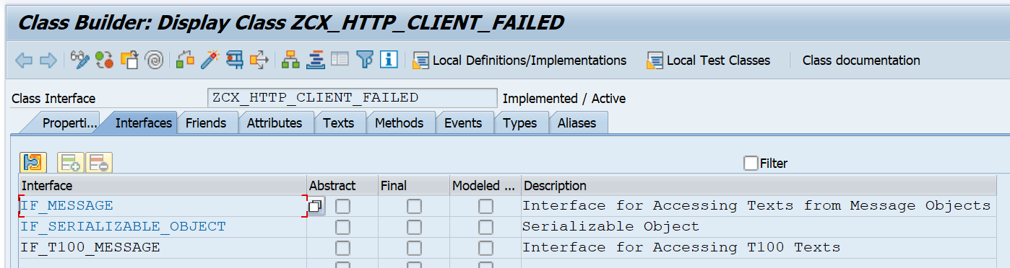

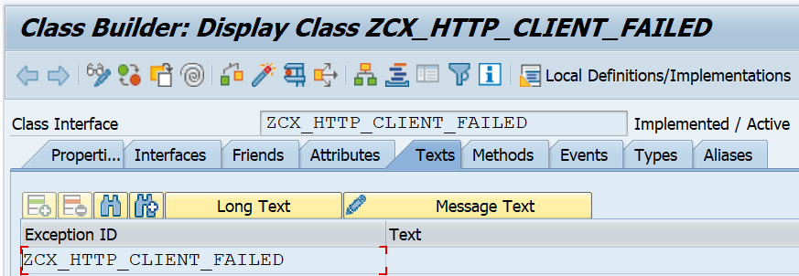

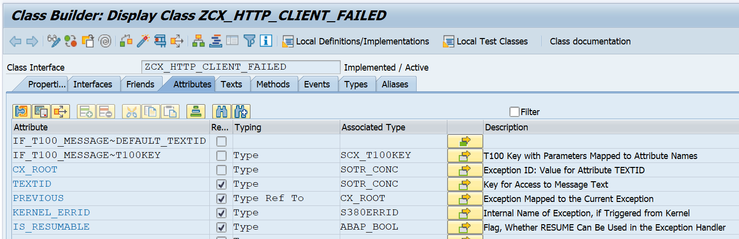

1. **ZCX_INTERACE_CONFIG_MISSING**

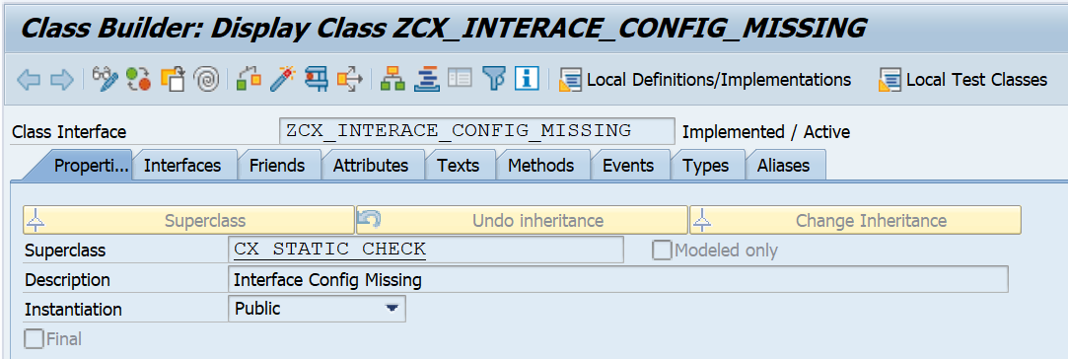

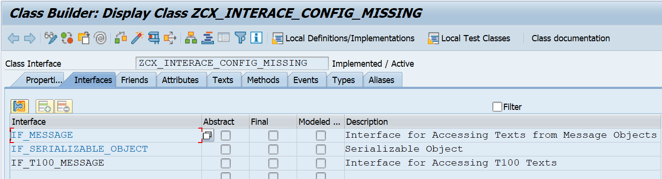

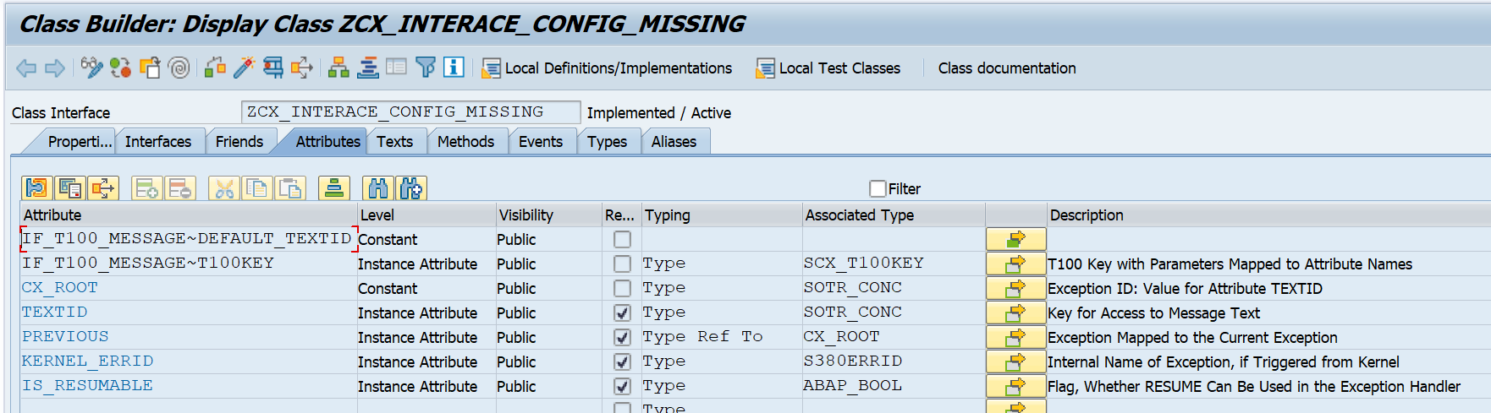

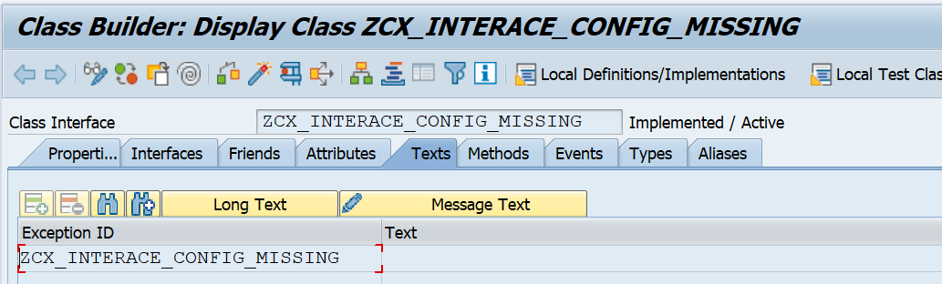

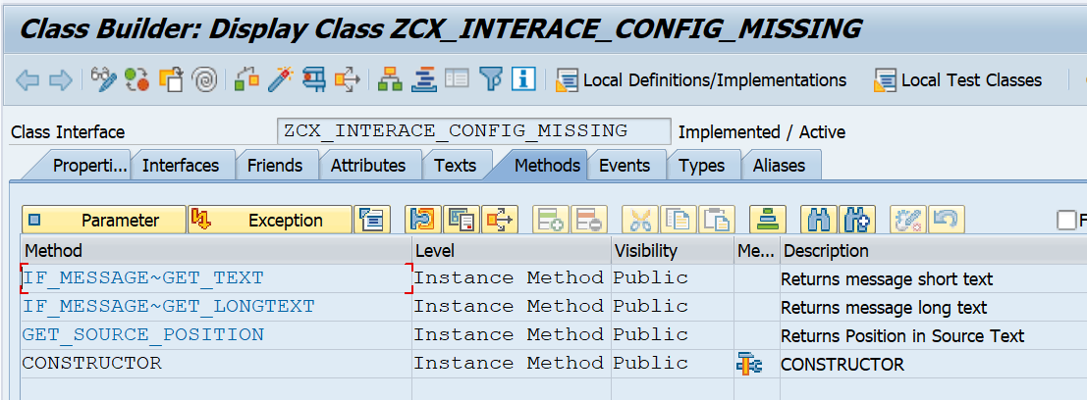

1. **Z_RESTCALL_FROM_DB**

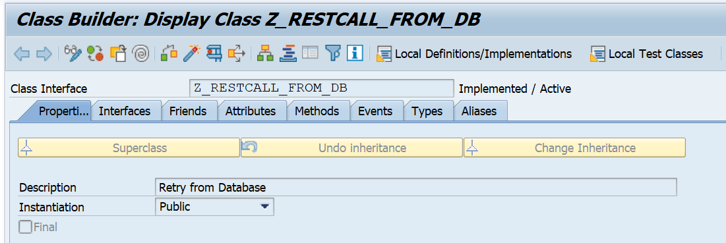

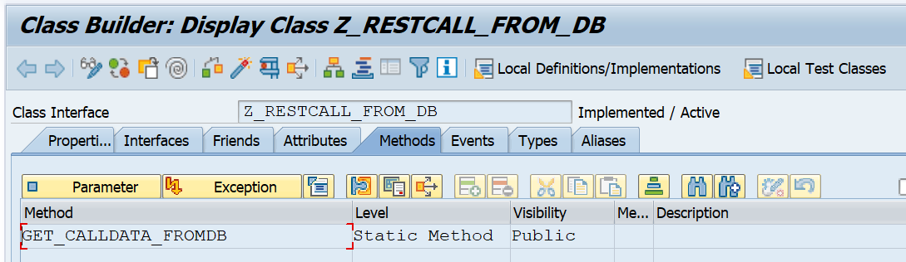

1. **ZCL_ADF_SERVICE (Abstract class)**

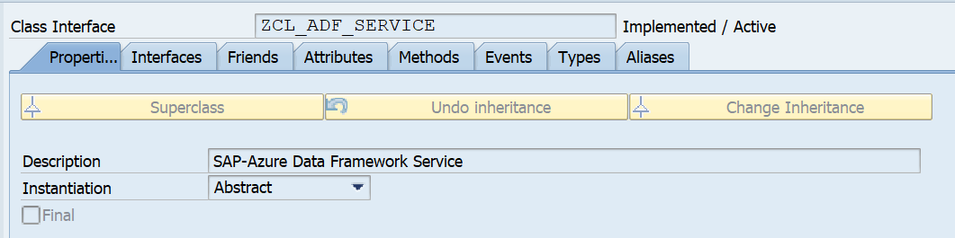

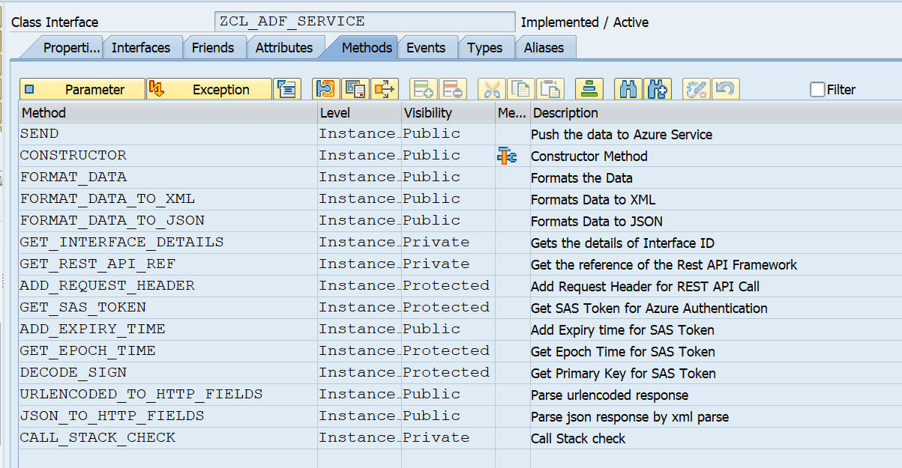

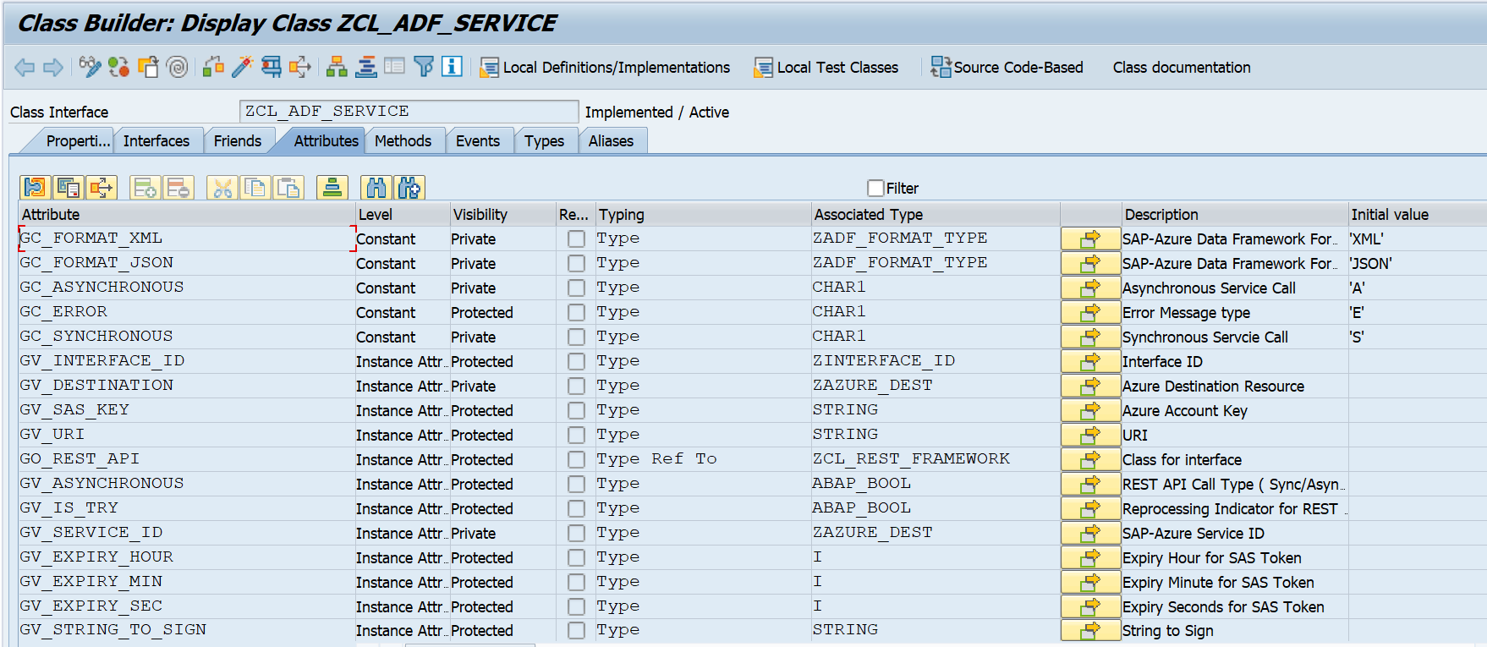

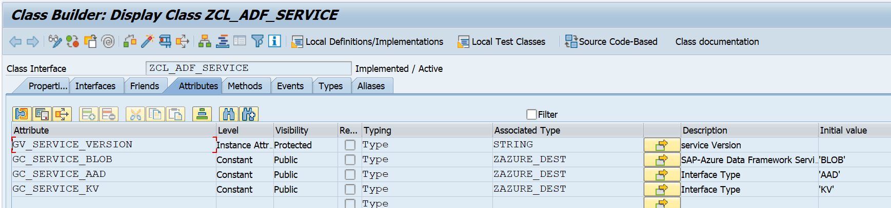

1. **ZCL_ADF_SERVICE_FACTORY (Factory class)**

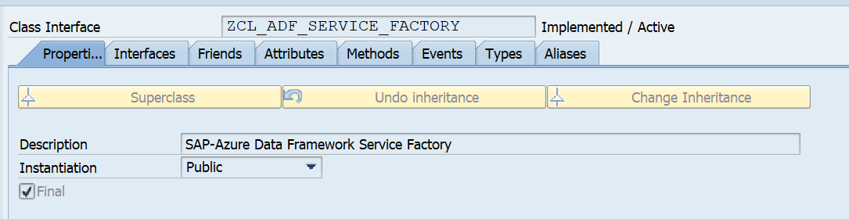

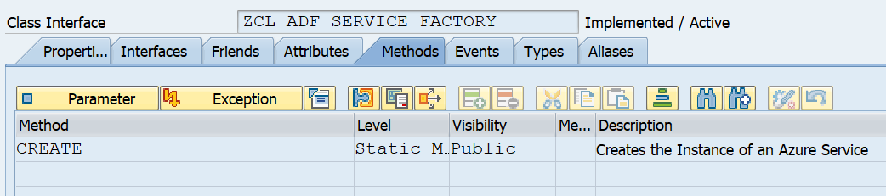

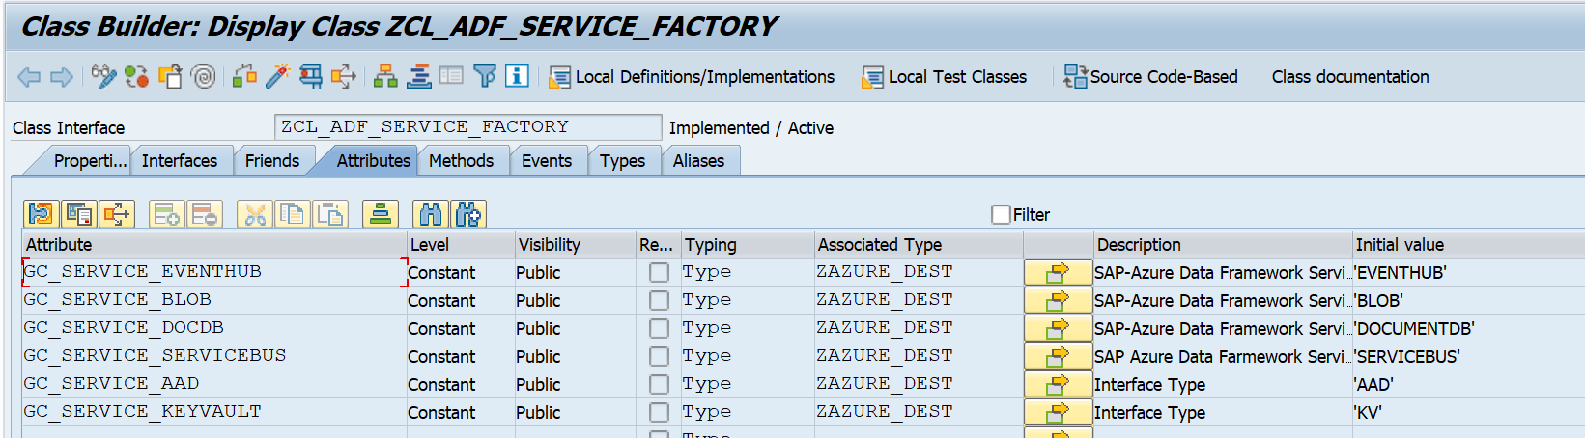

1. **ZCX_ADF_SERVICE (Exception Class)**

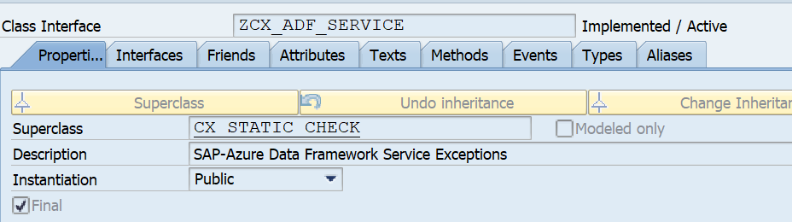

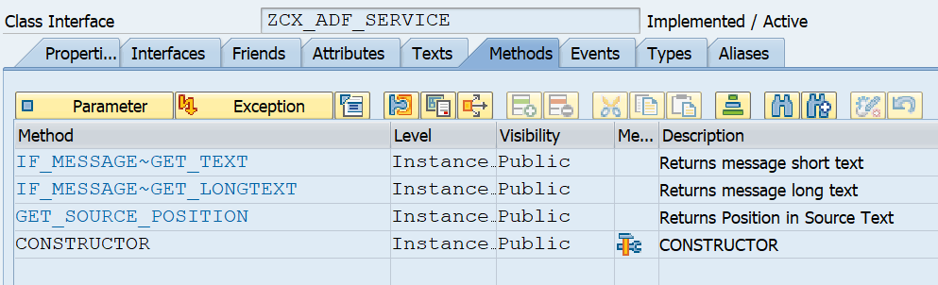

Exception Id and its corresponding texts (listed below) need to be maintained in the text section of

exception class.

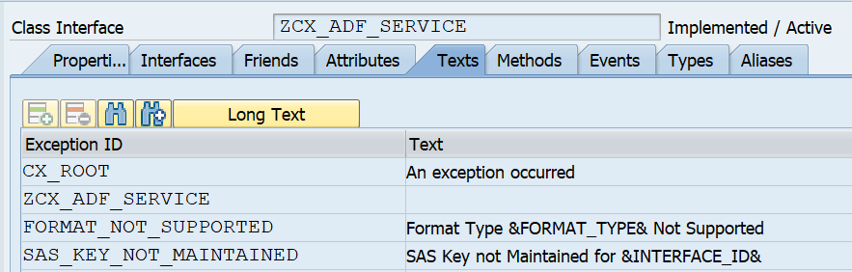

|  |  |
| --- | --- |
| **Exception Id** | **Text** |
| CX_ROOT | An exception occurred |
| ZCX_ADF_SERVICE |  |
| FORMAT_NOT_SUPPORTED | Format Type &FORMAT_TYPE& Not Supported |
| SAS_KEY_NOT_MAINTAINED | SAS Key not Maintained for &INTERFACE_ID& |
| URI_NOT_MAINTAINED | URI not Maintained for &INTERFACE_ID& |
| INTERFACE_TYPE_NOT_MAINTAINED | Interface Type not Maintained for Interface &INTERFACE_ID& |
| INTERFACE_NOT_AVAILABLE | Interface &INTERFACE_ID& not Available |
| SAS_KEY_NOT_GENERATED | SAS Key not generated for &INTERFACE_ID& |
| RESTAPI_RESPONSE_NOT_FOUND | Rest API response not found for &INTERFACE_ID& |
| CALL_TYPE_NOT_MAINTAINED | Service Call type not maintained for &INTERFACE_ID& |
| EXPIRY_TIME_NOT_SET | Expiry time not set for &INTERFACE_ID& |
| EXPIRY_UTC_TIME_NOT_SET | Expiry UTC time not set for &INTERFACE_ID& |
| ERROR_IN_SAS_KEY_ENCRYPTION | Error in SAS Key encryption for &INTERFACE_ID& |
| STRING_TO_SIGN_NOT_GENERATED | String to Sign not generated for &INTERFACE_ID& |
| ERROR_IN_APPEND_BLOB_CREATION | Error in AppendBlob creation for &INTERFACE_ID& |
| READ_ERROR_RFC_DESTINATION | Error in reading attributes of RFC destination for &INTERFACE_ID& |
| READ_ERROR_PSE_FILENAME | Error in getting PSE filename for &INTERFACE_ID& |
| ERROR_GET_CERTIFICATE_INSTANCE | Error in getting instance of certificate for &INTERFACE_ID& |
| ERROR_ATTRIBUTES_CERTIFICATE | Error in retrieving attributes of certificate for &INTERFACE_ID& |
| ERROR_DECODE_SAS_KEY | Error in decoding of SAS key for &INTERFACE_ID& |
| ERROR_CON_SASKEY_STRING | Error in conversion of SAS Key String for &INTERFACE_ID& |
| ERROR_IMPORT_SAS_KEY | Error in importing encoded SAS Key value for &INTERFACE_ID& |
| RFC_DESTINATION_NOT_MAINTAINED | RFC destination not maintained for &INTERFACE_ID& |
| ERROR_READ_ENCODED_SASKEY | Error in retrieving encoded SAS Key for &INTERFACE_ID& |
| ERROR_REST_API_INSTANCE | Error in Rest API instance creation for &INTERFACE_ID& |
| AAD_TOKEN_NOT_FOUND | AAD token not found for &INTERFACE_ID& |
| PARAMETER_INVALID_TYPE | Error in Epoch time calculation for &INTERFACE_ID& |
| PARAMETER_INVALID_RANGE | Error in Epoch time calculation &INTERFACE_ID& |
| ERROR_AAD_TOKEN | Error in receiving token from AAD for &INTERFACE_ID& |
| ERROR_RESTAPI_RESPONSE | Error in Rest API response for &INTERFACE_ID& |
| KV_SECRET_NOT_FOUND | Keyvault secret not found for &INTERFACE_ID& |
| EXECUTION_TERMINATED | Execution process terminated |
| PARSE_ERROR | Error in parsing Rest API response for &INTERFACE_ID& |

1. **ZCL_ADF_SERVICE_EVENTHUB (SAP-Azure Data Framework Event Hub Service)**

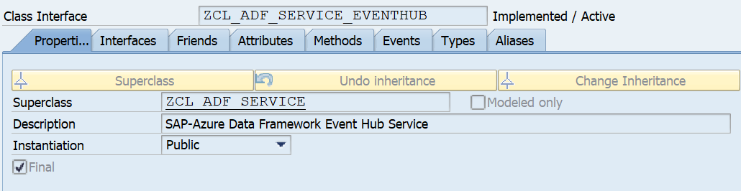

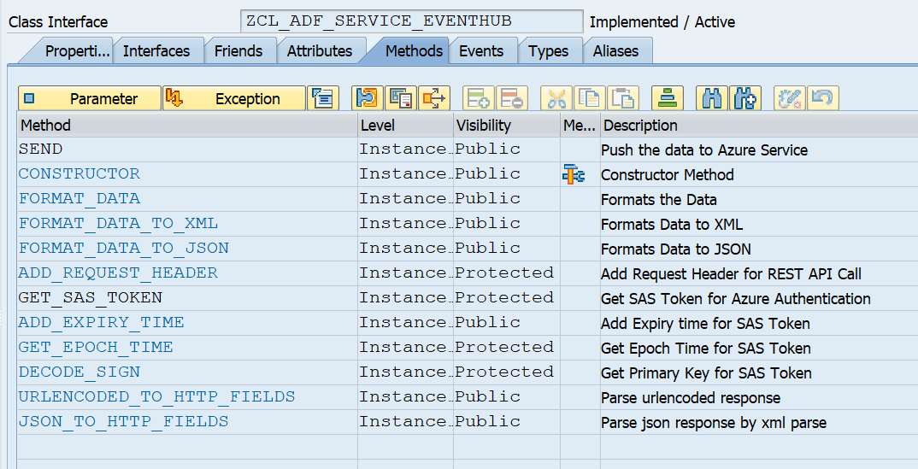

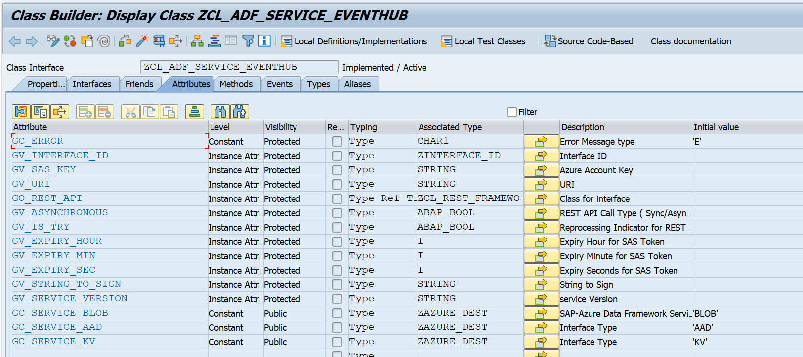

1. **ZCL_ADF_SERVICE_BLOB (SAP-Azure Data Framework Blob Service)**

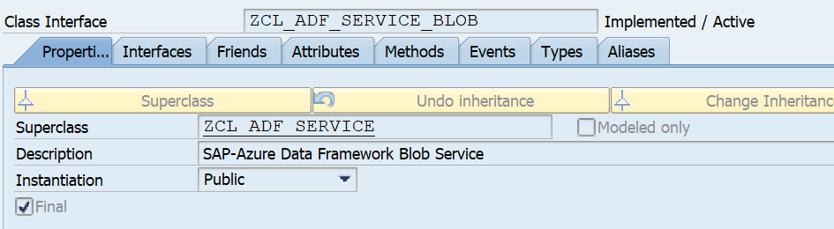

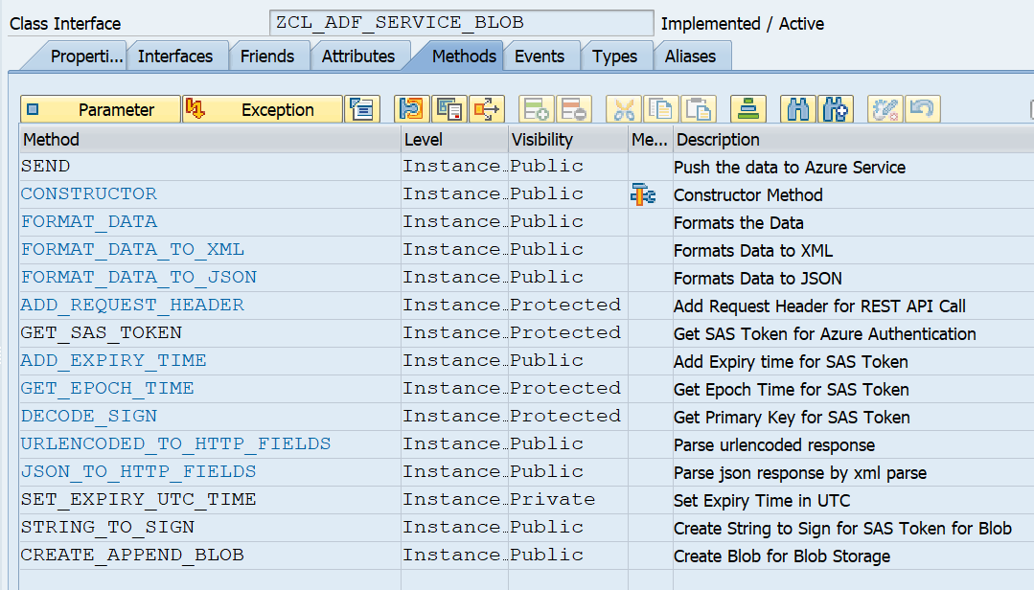

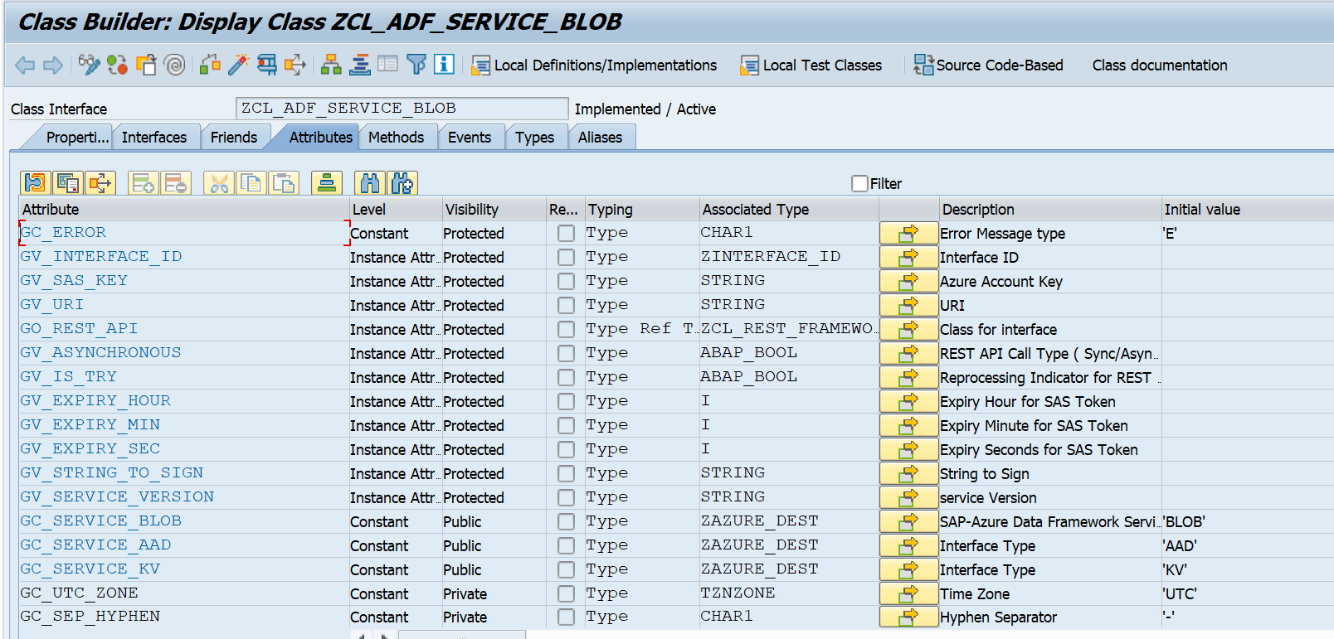

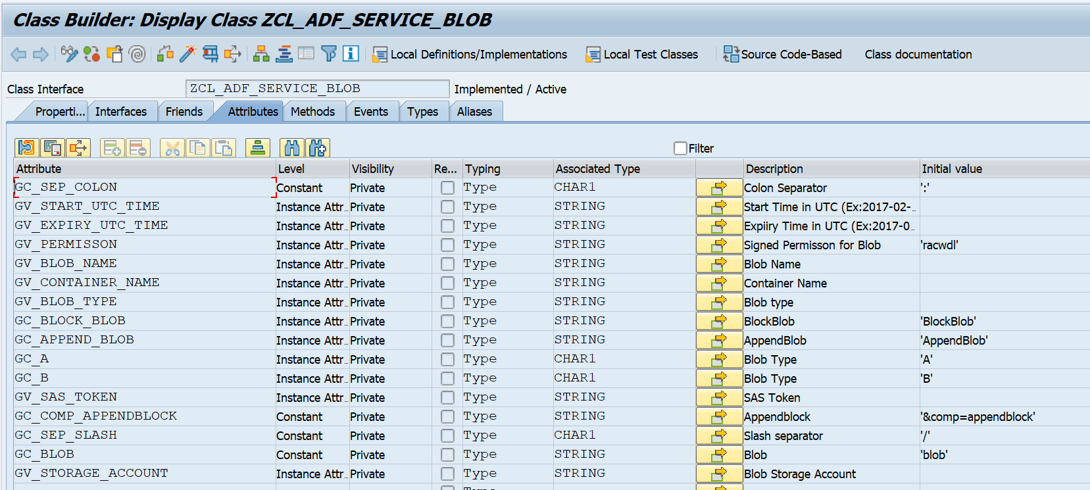

1. **ZCL_ADF_SERVICE_SERVICEBUS (SAP-Azure Data Framework Service Bus)**

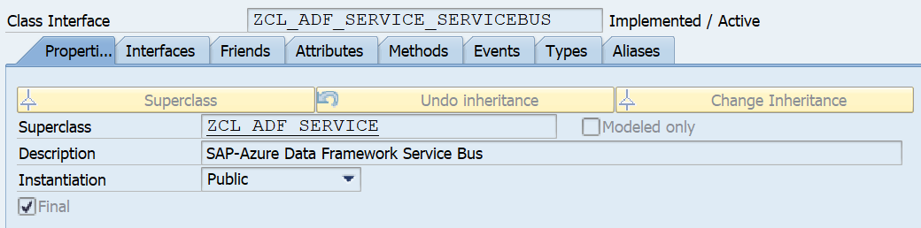

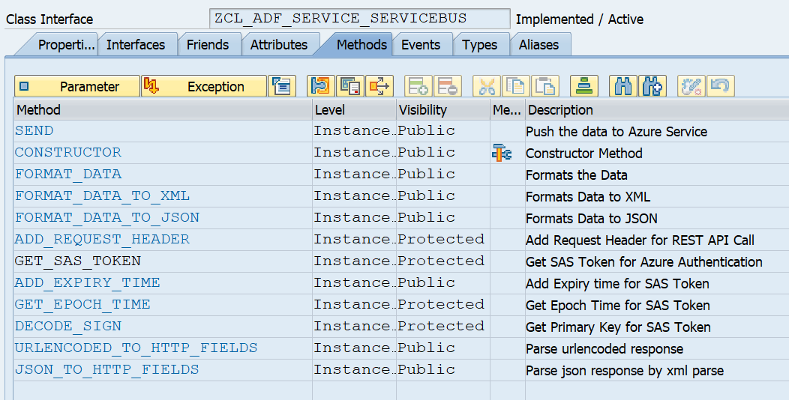

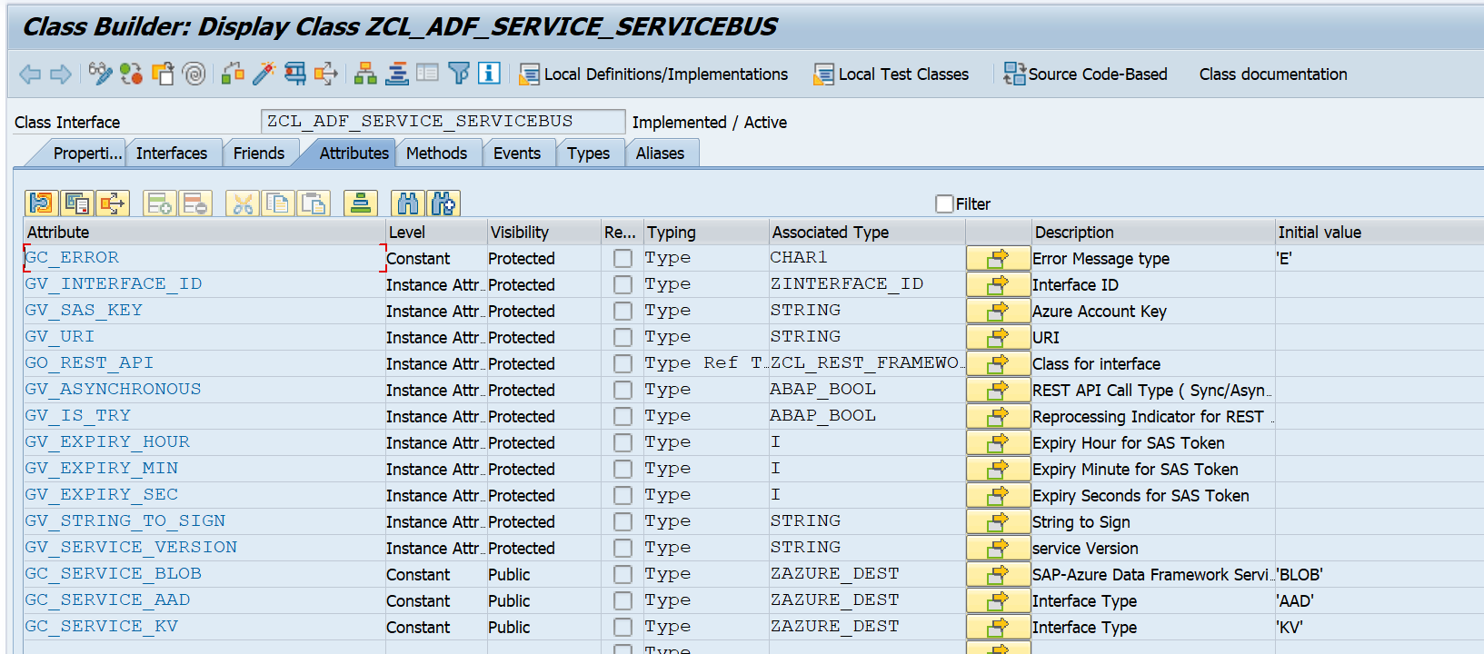

1. **ZCL_ADF_SERVICE_AAD (SAP- Azure Data Framework AAD service)**

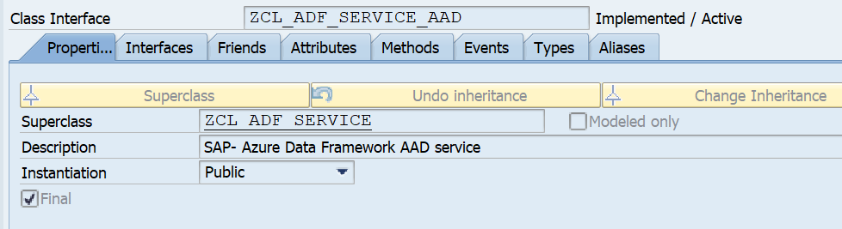

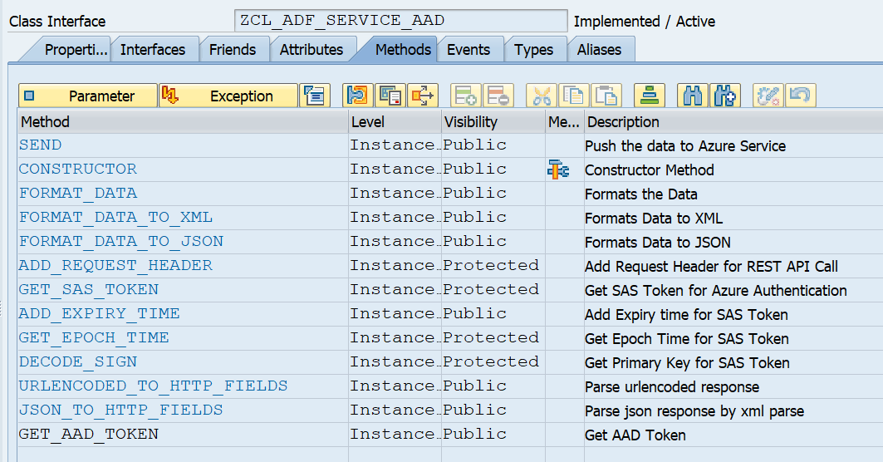

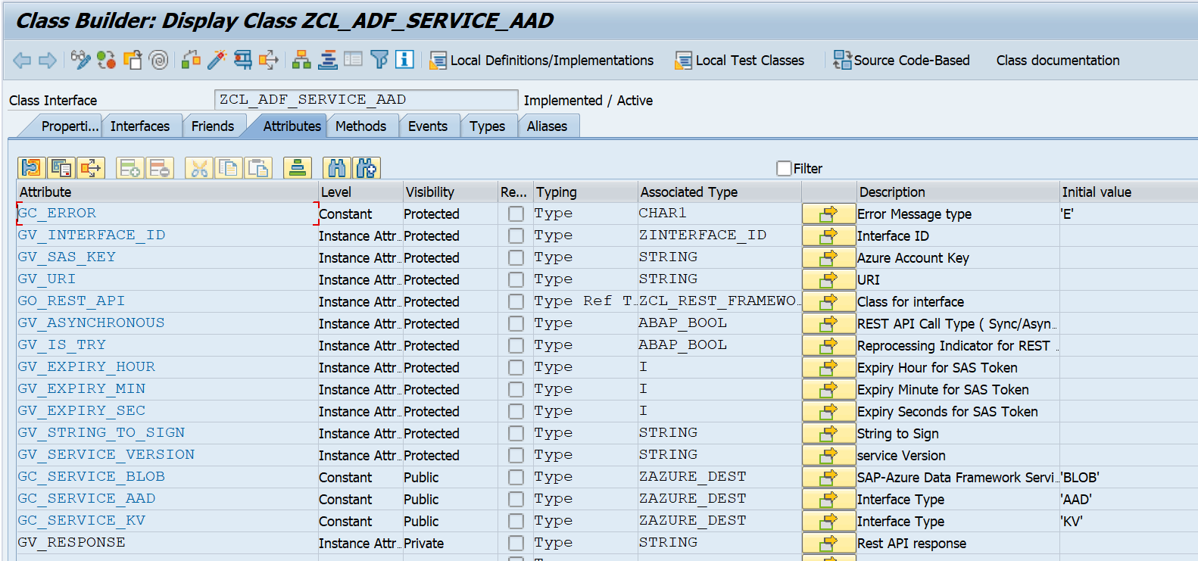

1. **ZCL_ADF_SERVICE_DOCUMENTDB (SAP-Azure Data Framework Document DB Service)**

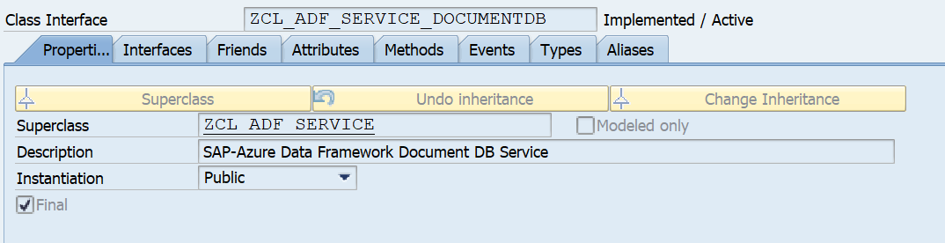

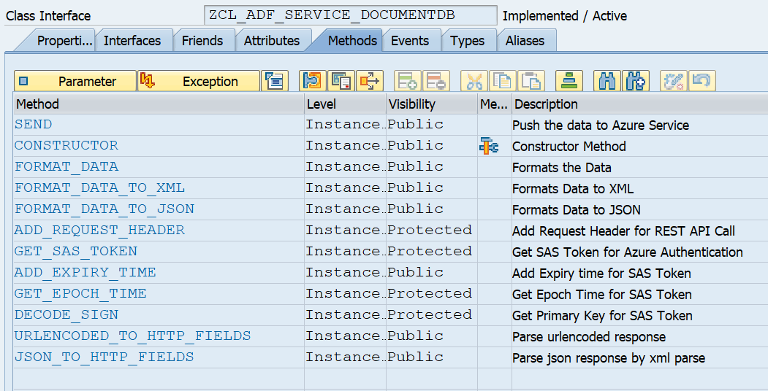

1. **ZCL_ADF_SERVICE_KEYVAULT (SAP-Azure Data framework Keyvault Service)**

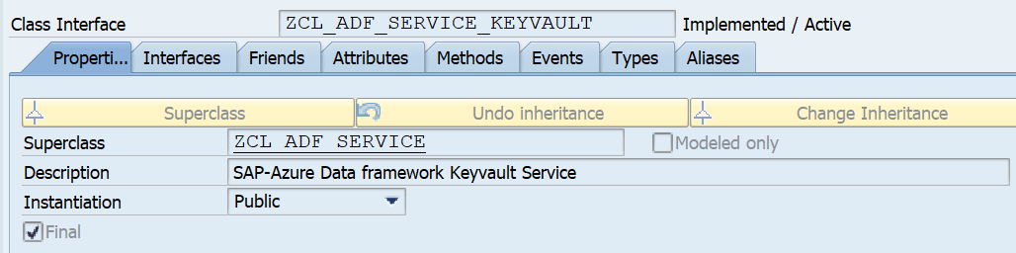

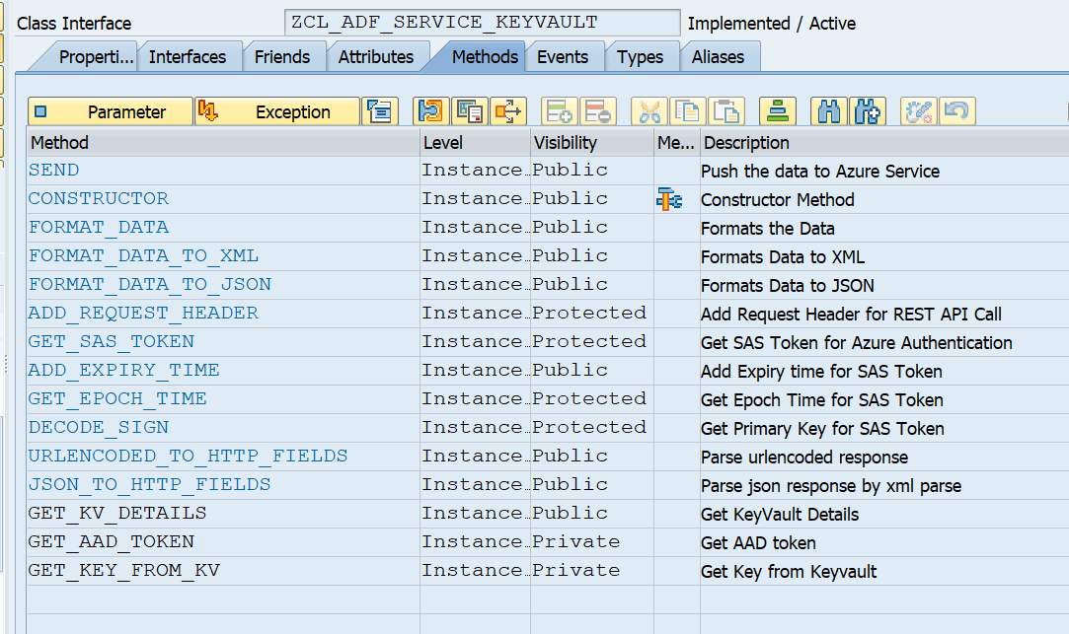

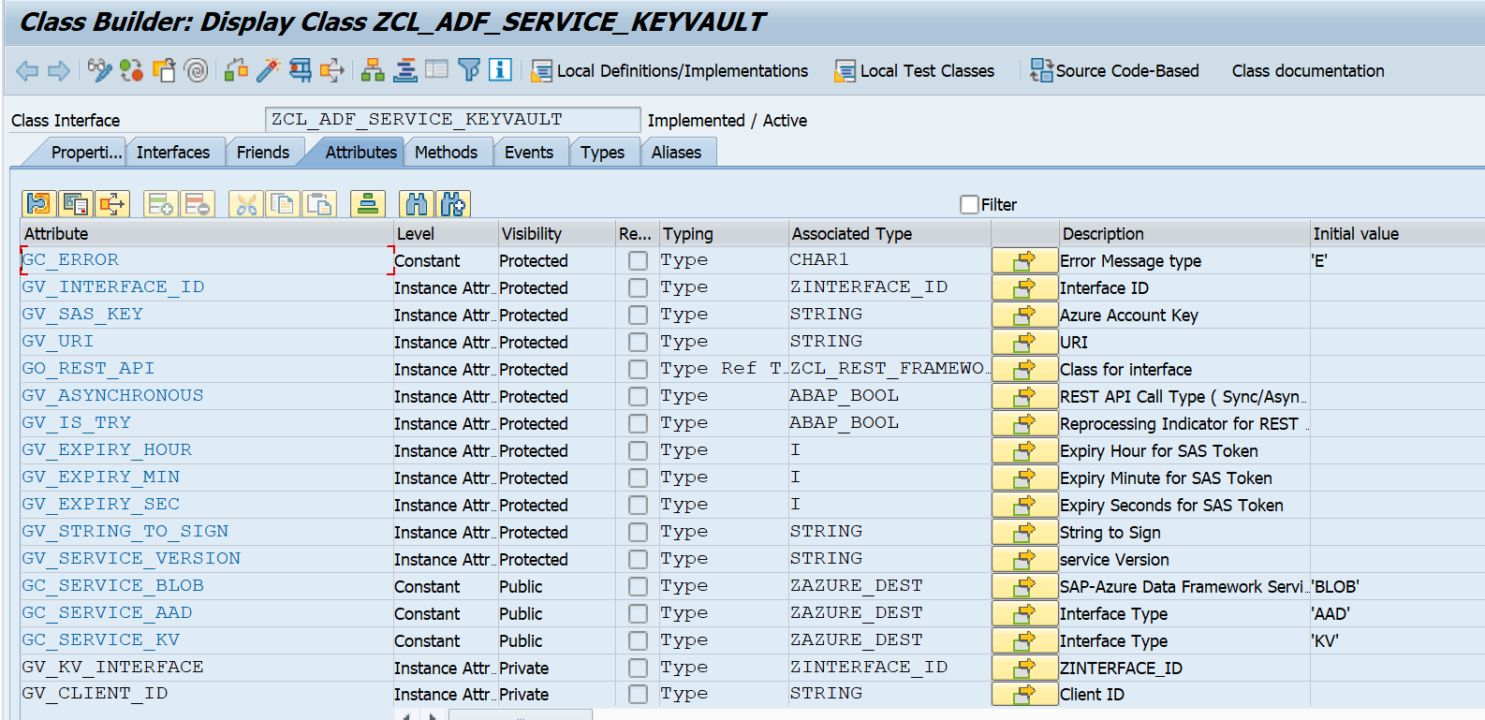

1. **ZCL_ADF_SQLDB (SAP-Azure Data Framework for SQL DB)**

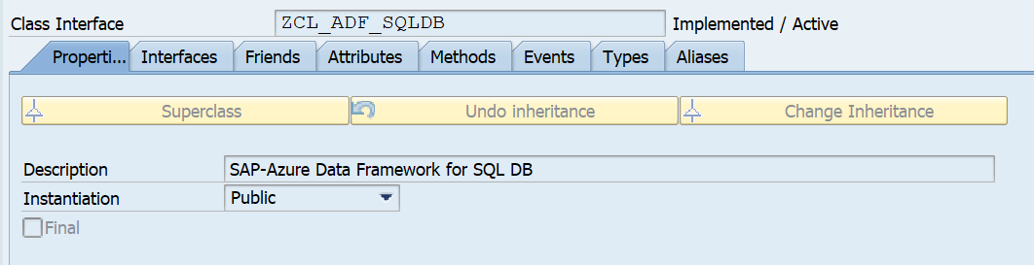

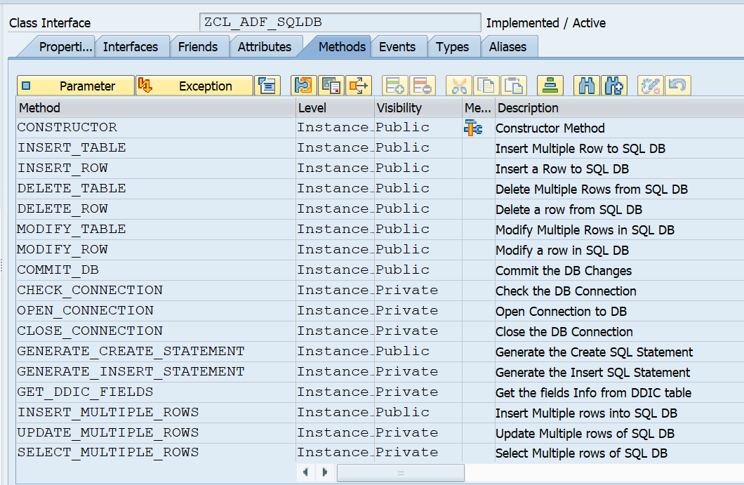

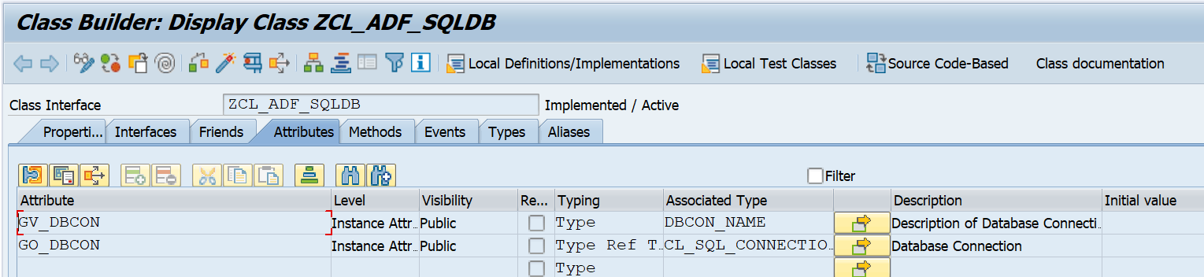

1. **ZCX_ADF_SQLDB (Exception class: SAP-Azure Data Framework SQL DB Exceptions)**

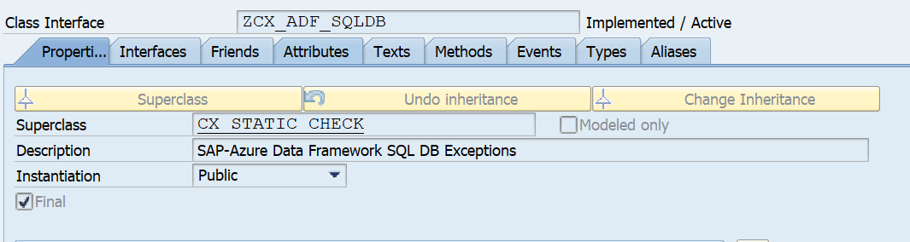

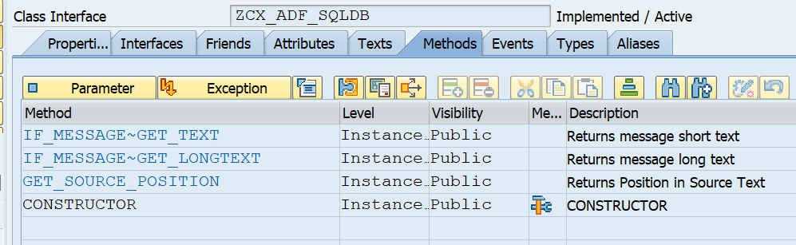

# Future Modification on Installation Guide

This installation guide has the details on initial version of ABAP objects required for ABAP SDK for AZURE. In successive versions we will extend the ABAP SDK library and incorporate more Azure Service features.